LESSON NOTES FOR RELIGIOUS EDUCATION
THEME: DISCOVERING GOD’S GIFTS TO ME.
SUBTHEME: NAMES AND THEIR MEANING
Christian names
- For boys
e.g Emmanuel, Isaac, Stephen, James
- For girls
e.g Mary, Catherine, Jovia, Annet, Ruth
Moslem names
- For boys
e.g Ali, Majir, Musa, Abdallah
- For girls
e.g Aisha, Halima, Hasfa, Amina

Evaluation Questions
- Write 3 Christian names for girls.
- Mention two (2) Christian names for boys.
- Write any three Moslems names.

SUBTHEME: MEANINGS OF NAMES
Examples
Peter – means rock
Emmanuel – God is with us
Moses – picked from water
John – the love one
Kirabo – Gift from God
Kisakye – God gives mercy
Suubi – God gives hope
Abraham – father of believers
Sarah – mother of believers
Irene – Peace
Kwagala – God is love

Evaluation questions
- Give the meaning of the following names.
- Abraham
- Moses
- Emmanuel
- Kirabo
- Match correctly.
John means rock
Kisakye the loved one
Sarah mother of believers
Peter God gives mercy

SUBTHEME:I AM PART OF GOD’S CREATION (PARTS OF THE BODY)

- eyes
- legs
- nose
- mouth
- hair
- arm
- tongue
- neck
- hands
- ears

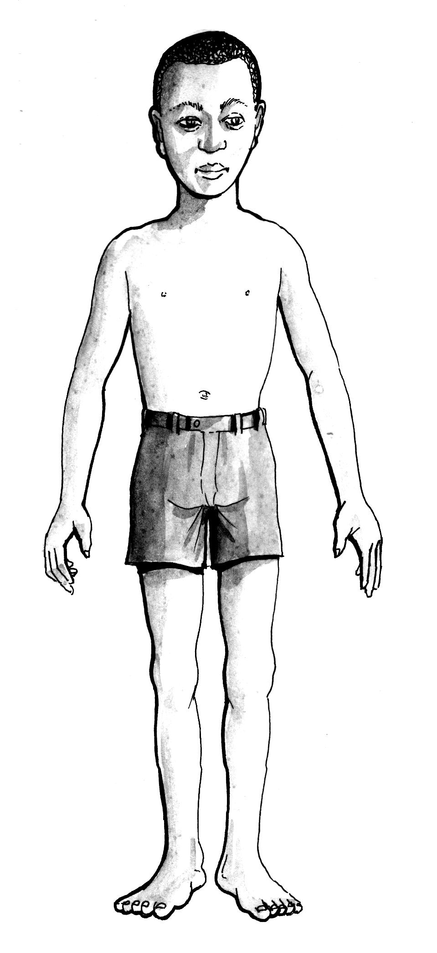
toes
leg
hand
arm
nose
ear
hair

Evaluation questions
- Mention any (4) gifts God gave us.
- Draw these gifts God gave us.
- eyes
- ears
- nose
- leg
SUBTHEME: PARTS OF THE BODY
nose ears eyes
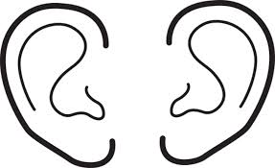
head legs arm
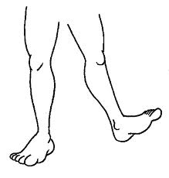

hands
Evaluation questions
Name these gifts God gave us.
……………………………………………………………………
……………………….…. ……………………………….

USES OF GOD’S GIFT TO ME
Legs are used for walking
Eyes are used for seeing
Tongue is used for tasting
Nose is used for smelling
Hands are used for touching, holding, writing, washing and carrying.
Evaluation questions
- When did God give us these gifts?
- the nose
- the hands
- the legs
- Complete the following
are for………………………………………..
are for …………………………………………..
SUBTHEME:CARING FOR OUR BODIES.
Ways of caring for our bodies.
- by bathing everyday
- by brushing our teeth
- by combing our hair
ABLUTION: This is done by moslems when they wash their body parts before going for prayers. They wash their hands, feet, face,
- by cutting our finger nails short
- by washing our clothes

Evaluation questions
- How do we keep our body clean?
- Mention three body parts which moslems wash before going for prayers.
SUBTHEME: WHY WE CLEAN OUR BODIES.
- To prevent disease.
- To avoid bad smell.
- To keep our body healthy.
- To control the spread of diseases.

Evaluation questions
- Give four reasons why we should keep our bodies clean.
SUBTHEME: OUR FAMILY MEMBERS AS GIFTS FROM GOD
Examples of family members
- mother
- father
- children
- nephew
- uncle
- aunt
- cousins
- grandmother
- grandfather
- niece
Questions
- Write down two family members.
- Draw these family members.
grandmother | father | baby

SUBTHEME: PARENTS AS GIFTS TO US.
Importance of parents to us.
- To look after us
- They teach us good manners
- They take us to church
- They protect us from danger

Question
- Give four importance of parents to us.
SUBTHEME: People at school as gifts from God to us.

- headteacher
- secretary
- matrons
- pupils
- director
- cleaners
- gatekeeper
- deputy headteacher
- teachers
- cooks
- bursar
- nurse

Evaluation questions
- Write these words correctly.
- chools
- ronsmart
- rsabur
- koocs
- Draw these people found at school as gifts from God.
- teacher
- headteacher
- pupils
- cleaners

Ways how people at school help us.
- They teach us.
- They protect us.
- The teach how to relate with others.
- They clean the compound.
- They help us to know God.
- They help us to be happy.
Evaluation questions
- Give 4 ways how people at school help us.

SUBTHEME: PEOPLE IN THE COMMUNITY AS GIFTS FROM GOD TO US.
People who serve us in our community are:
- doctors, shopkeepers, pilots, carpenters, teachers, barbers, nurses, drivers farmers etc
Evaluation questions.
1. Name four people who serve us in our community.
2. Draw the following people found in the community.

- farmer
- teacher
- nurse

SUBTHEME: OUR GIFTS TO GOD.
Kinds of gifts we can give to God to thank Him for His gifts to us are:

-giving money as offerings in the church.
-we give gifts to others.
-we serve God.
-we serve others.
-we preach the word of God to people.

SUBTHEME: HELPING PEOPLE IN NEED.
These are people who need special help or care.
- old people
- lame people
- sick people
- mad people
- poor people
- pregnant mothers
- orphans
- homeless people
- dumb people
- the babies
- blind people
Evaluation questions:
- Mention four people in need.
- Draw these people who need help.
- baby ii) lame man iii) old woman

How to help the above mentioned people
- carrying things for them.
- taking them to hospital.
- giving them food.
- guiding them.
- giving them shelter.
- praying for them.
- giving them gifts.
- giving them water.
Evaluation questions
- Mention any two groups of people in need.
- How do we help the people in need?
SUBTHEME: GOD’S CREATION
Things God created.
Plants, birds, grass, hills, fish, lakes, mountains, animals, rivers, stones, trees, people, insects, animals, rivers, stones, trees, people, insects,
God created all these things in six days
Evaluation questions
- Draw and name three things God created.
- Name the things that God created.
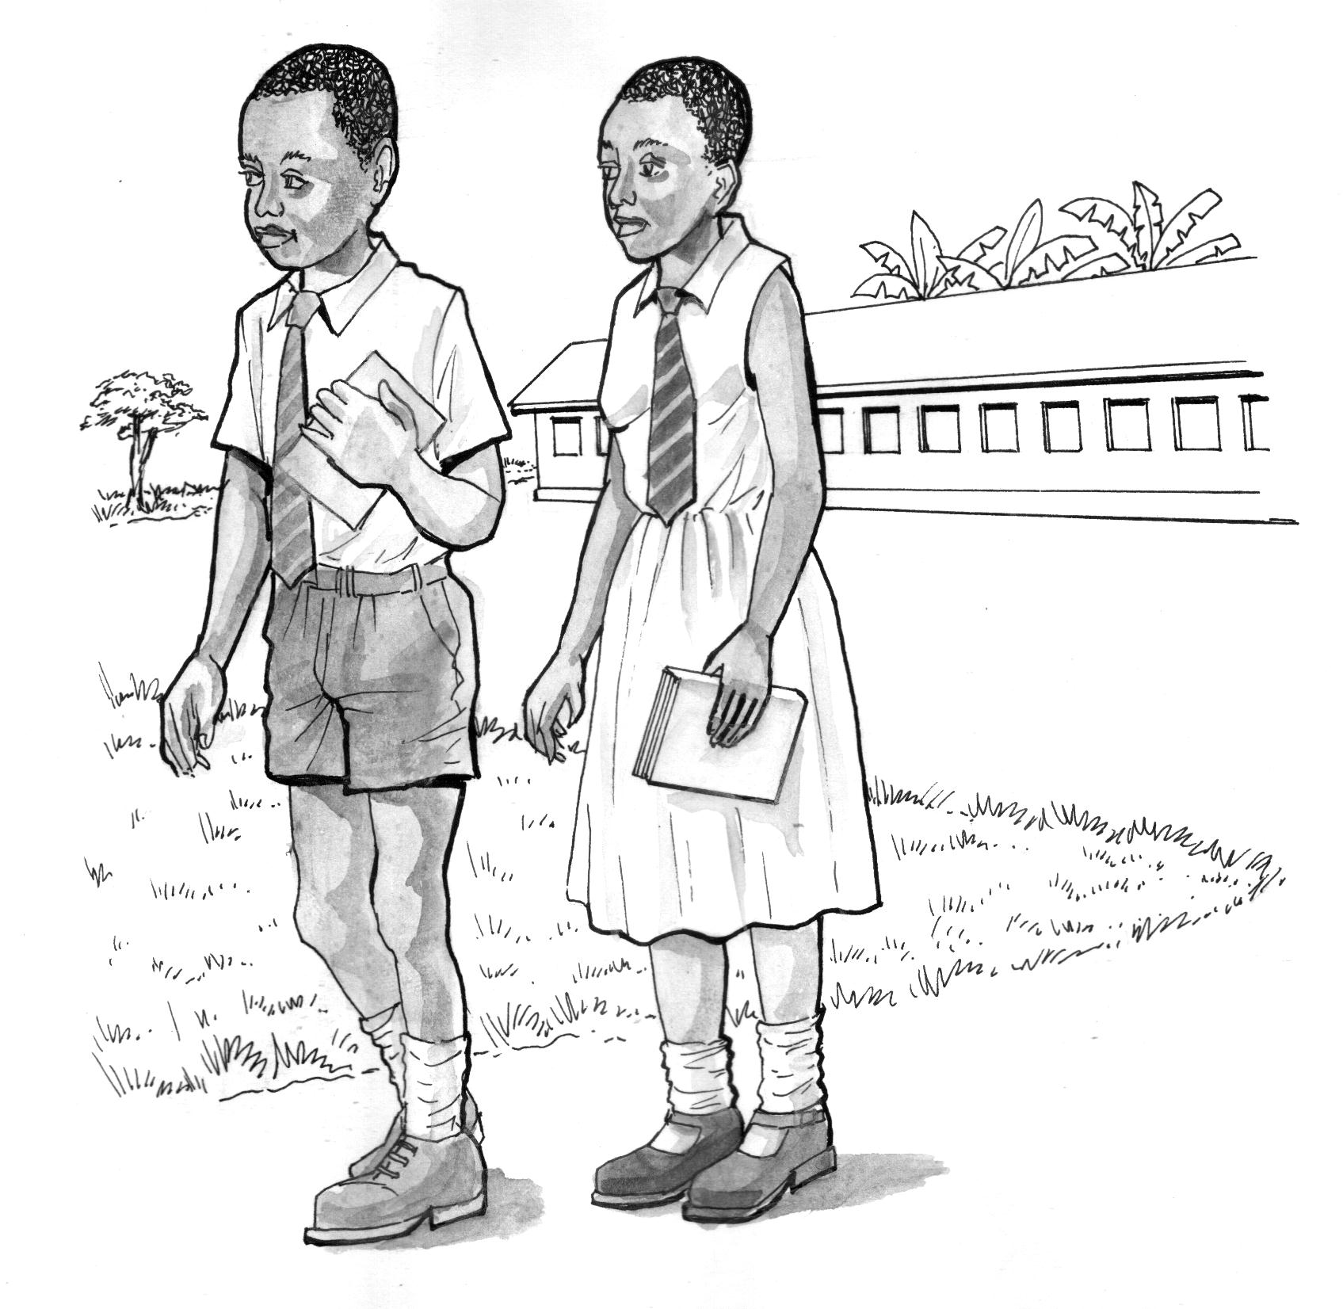 | 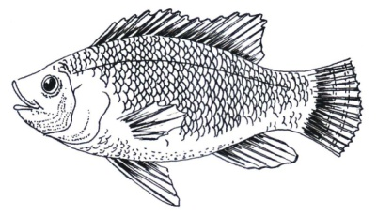 | 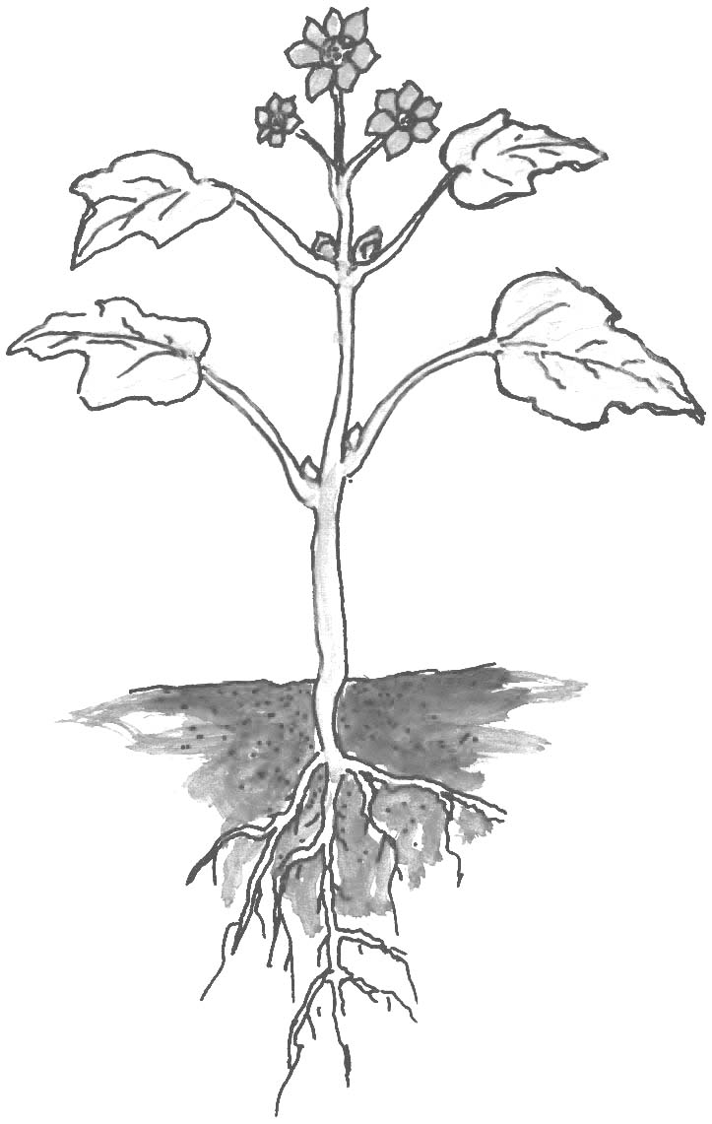

- God created the world in ………………………………………..days.

SUBTHEME: THINGS GOD CREATED TO GIVE US LIGHT.
moon, sun, star

moon sun star

Evaluation question
- Name this source of light.
- Write down any two things God created to give us light.
- Draw these things God created to give us light.
- Stars ii) sun
- Name the things God created to give us light during

- day time
- night time

SUBTHEME: USES OF GOD’S CREATION
God created man.
The first man God created was Adam. The first woman God created was Eve. Eve was the wife of Adam. God created people to rule and control the other creations.
Evaluation questions:
1.Name the first man God created.
2.Who was the wife of Adam?
3.Why did God create man?
4.Draw Adam and Eve.
SUBTHEME: GOD CREATED PLANTS:
God created different plants eg. Bean plants, maize plants, cassava plants, orange plants, water melon plants etc
Evaluation questions:
- Name four plants you know.
- Draw these plants
- Cassava plant ii) mango plant iii) banana plant

God created different plants. Some of these plants provide us with food, fruits and medicine.
Plants that provide food are: beans, cassava, sweet potatoes, maize etc
Plants that provide fruits are: oranges, mangoes, avocados, apples etc
Plants that provide medicine are; bombo aloevera, mululuza, black jack etc
Evaluation questions:
1.Give any two plants provide the following:
a) food ……………………………., …………………………………
b)fruits …………………………….., ………………………………..
c) medicine …………………………., ………………………………
2. Draw and name two fruits.

LESSON NOTES FOR RELIGIOUS EDUCATION
THEME: DISCOVERING GOD’S GIFT TO ME
SUB-THEME: The world God has created for us.
God created the world in six days (Gen.1:1-31)
Examples of things God created are:

DAYS | CREATION |  | COMMENT
In the beginning | Heaven, earth |  | There were people, animals or light
First day | Light ( day and night) |  | That was the first day
Second day | Sky ( water on land and clouds) |  | That was the second day
Third day | Land, hills, rivers, lakes, valleys |  | That was the third day
Fourth day | Sun, moon, stars |  | That was the fourth day
Fifth day | All kinds of fish in water and birds in the air |  | That was the fifth day
Sixth day | Animals, beasts, the first people( Adam and Eve) | God made man in His image and gave him power to rule all creatures
Seventh day | God rested from creation | That is why we work for six days and rest on the seventh day. We have to go and worship Him

- In how many days did God create the world?
- Mention five things created by God.
- Why did God create human beings?
- Draw these things God created

stones plants birds people

SUB THEME: The first people God created.
God created light first and man last.
The first people God created were Adam and Eve.
Eve was the wife of Adam. They lived in the Garden of Eden.
God put everything that these people needed in the garden.
They had two sons Abel and Cain.
Cain killed Abel because he was much loved by God.
God created man to care for His creation.
Exercise:
- What did God create on the first day?
- On which day did God create man?
- Name the first man God created.
- Who was the wife of Adam?
- Who were the two sons of Adam?
- -------------------------------- killed Abel.
- Why did Cain kill his brother?
SUBTHEME:
Creation of the sky
God created sources of light in the sky. These are: sun, moon and stars.
The sun was created to give light during day time while the stars and moon to give light
during night time.
God also created clouds in the sky to give us rain.
Sun is the main natural source of light.
Exercise:
1. Name the three sources of light God created in the sky.
2. What is the main natural source of light?
3. The ---------------- gives us light during day time.
4. God created ------------------------- and ---------------------------- to give light during night time.
5. Why did God create he clouds?
6. Draw these sources of light God created.
sun | moon | stars

SUB-THEME: Uses of God’s creation (Uses of the sun)
Uses of the sun
- The sun is the main natural source of light and heat
- We get light from the sun.
- The sun dries our clothes.
- We get vitamin D from the sun.
- The sun dries our seeds.
- The sun gives us warmth.
Exercise:
- What is the natural source of light?
___________________________________________________________________________
- Name these sources of light God created.

__________________ _____________________
- Write down any three uses of the sun.
- ________________________________________________________________________
- ________________________________________________________________________
- ________________________________________________________________________
- The ------------ is to day time while --------------- and ------------- are to night time. (moon, sun, stars)

SUB- THEME: Uses of God’s creation (Uses of animals)

Uses of the animals
- We get milk from some cows.
- We get meat from some animals.
- We get skins from some animals.
- We get wool from some sheep.
- A dog guards our homes.
- Oxen are used for ploughing.
- Some animals are used for transport e.g. horses, camels, donkeys.

Exercise:
- Name any four animals God created.
- How are animals useful to people? ( Give two ways )
- Name the animal that chases away rats in a home.
__________________________________________________________________________________
- Which animal guards people’s homes?
__________________________________________________________________________________
- Write down two things we get from a cow.
- ___________________ ii)______________________
- Why should people keep oxen?

SUBTHEME: Uses of birds
- We get eggs from some birds.
- We get meat from some birds.
- We get manure from birds.
- We get feathers from birds.
Exercise:

1. How are birds useful to people? (State two ways)

2. Mention two things we get from birds.

(a)------------------------------------------ (b) ----------------------------------------------

3. Draw and name two birds you know

SUB THEME: Uses of plants.
- We get food from plants
- We get medicine from plants
- We get firewood from some plants.
- Some plants give us flowers for decoration.

Exercise:
- How are plants useful to people? (State three ways )

- Mention two things we get from plants:
- __________________________________________________
- __________________________________________________
- Draw these plants below
Pawpaw tree | Flower plant

SUB-THEME: CARING FOR GOD’S CREATION
Animals: vocabulary: food, water, shelter, treatment, care, giving
Ways of caring for animals

- giving them food
- giving them water
- treating them
- building for them shelter

Activity
Write down three ways how we can care for animals
- ____________________________________________
- ____________________________________________
- _____________________________________________
What may happen to domestic animals if they are not well cared for?
- ____________________________________________
- ____________________________________________
- _____________________________________________
Plants
Ways of caring for plants
Vocabulary: weeding, pruning, mulching, thinning, watering
We care for plants by

- Weeding
- Pruning
- Mulching
- Thinning
- Watering them
- spraying them

Activity
Mention four ways how plants are cared for
- ___________________________________________________
- ___________________________________________________
- __________________________________________________
- ___________________________________________________
What can happen to plants if they are not?
  - watered………………………………………
  - weeded……………………………………….
What would happen to man is God did not create animals and plants?
- ___________________________________________________
- ___________________________________________________
- __________________________________________________
- ___________________________________________________

Sub – theme: Jesus’ home and childhood
Luke: 2:39 – 40, 51 – 52
Jesus was born in Bethlehem. When Mary was in labour
Pains she was taken in a kraal by Joseph earthly father of Jesus
After the child was born, he was put in a manger
Jesus was given gifts from the three wise men.
The gifts that were given to him were: myrrh, Gold and francinces
Jesus grew up in the city of Nazareth
Every year at the feast of Passover they went to Jerusalem as a custom
When Jesus twelve years he remained in the temple preaching the word of God
Jesus was baptized by John the Baptist in river Jordan
Jesus was going to be killed by King Herod
Activity
- Pupils will role play a skit how the wise men brought the gifts
- Pupils draw pictures Jesus in the manger in the kraal

SUB THEME: JESUS BLESSES LITTLE CHILDREN (MATHEW: 19: 13 – 15)
Jesus was preaching to people when little children were brought to Him that he might put his hands on them and pray
The disciples were not happy when they saw that, so they rebuked the children. But Jesus said, let the little children come to me and do not stop them, for of such the kingdom of heaven is theirs. When the children heard this, they were very happy. So Jesus hugged them and blessed them.
Activity
- The pupils will be to role play the story told to them.
- Draw pictures showing Jesus with the children.

SUB-THEME: ACCEPTING JESUS’ CALL AND FOLLOWING HIM. (MARK 3: 13 – 19) LUKE 6: 12 -16
Jesus went up a hill to pray and spent the whole night there praying to God. When day came, he called his disciples and chose twelve of them, whom he named apostles
- Simon Peter. (denied Jesus) (John 18:15 – 27

- Andrew
- James
- John
- Philip
- Bartholomew
- Mathew
- Thomas
- Thaddeus

- James son of Alphaeus
- Simon son of Patriot
- Judas Iscariot (betrayed Jesus)
Activity
- Who betrayed Jesus?
__________________________________________________________________________________
- Name the disciple who denied Jesus.
__________________________________________________________________________________
- How many times did he deny Jesus?
__________________________________________________________________________________
- Why did Jesus have apostles?
__________________________________________________________________________________
SUB-THEME: EVENTS OF JESUS’ MINISTRY
During his life Jesus performed miracles
Jesus changed water into wine (it was his first miracle in Cana. (John 2: 1 -12)
- Jesus walks on the water. (John 6:16 – 21
- Jesus fed a great crowd (John 6:1 -15) – 5 loaves and 2 fish
- Jesus heals a man born blind (John 9: 1-1) the lame
- Jess rose the dead like Lazarus (John 11: 38 – 44)
- Jesus healed many people. (Luke 4: 38-41)
Sub –theme: types of prayer
Prayer (Luke 11:5-12)
A prayer is the way one talks to God.
Types of prayer
- Lord’s prayer
- Thanks giving prayer
- Request prayer
- praising prayers
Activity
- A _____________________is the way one talks to God.
__________________________________________________________________________________
- Mention two types of prayers
    - __________________________________________________________
    - __________________________________________________________
- Why did Jesus feed the hungry?

How one talk to God?
- People talk to God
- Through praying
- Through singing praise songs
- Through Bible study

Activity
How do people talk to God? (Give two ways)
- ___________________________________________________________________
- ___________________________________________________________________

SUB THEME: WAYS OF ASSISTING OTHERS
Jesus meets Zacchaeus. Luke 19:1 – 5
In the Bible, there is a story of a man called Zacchaeus
He was a very short man. He was a chief tax collector.
One day when Jesus was passing by, Zacchaeus climbed a sycamore tree to see Him. When Jesus saw him, he told Zacchaeus to come down. Then Jesus went to Zacchaeus’s home and had lunch with him.
Activity
  - What is the name of the man in the story?
__________________________________________________________________________________
  - What was the work of the man in the story?
__________________________________________________________________________________
  - Which tree did Zacchaeus climb to see Jesus?
__________________________________________________________________________________
  - Why did Zacchaeus climb the sycamore tree?
__________________________________________________________________________________
  - Write the title of the story.
__________________________________________________________________________________
The death of Lazarus (John 11:1 – 44)
A man named Lazarus, who lived in Bethany, was ill.
He had two sisters Mary and Martha who were great friends to Jesus. They sent a message to Jesus “Lord, your dear friend is ill. When Jesus received the message he stayed where he was for two more days.
Jesus told the disciples to go back to Judea that their friend Lazarus had fallen asleep meaning that Lazarus was dead.
Jesus found that Lazarus had been buried for four days before.
Jesus went to the tomb, Jesus looked up and prayed to his father, after praying he called out in a loud vice, Lazarus come out. He came out.
Activity
  - What is the name of the man in the story?
__________________________________________________________________________________
  - How many sisters had Lazarus?
__________________________________________________________________________________
  - Why did Lazarus sisters send a message to Jesus?
__________________________________________________________________________________
  - Why did Jesus go to Lazarus’ tomb?
__________________________________________________________________________________
Jesus fed a great crowd (Luke 9:12 – 17)
Jesus fed 5000 people using the five loaves and two fish
Jesus took the five loaves and two fish, looked up to heaven thanked God for them, broke them and gave them to the disciples to distribute to the people. They all ate and had enough and the disciples took up twelve baskets of what was left over.
Activity:
- How many people did Jesus feed?
__________________________________________________________________________________
- Mention two things that Jesus fed people.
i)______________________________________ii)_________________________________________ Mention the miracle that Jesus performed according to the story.
__________________________________________________________________________________
- Why did Jesus feed the crowd?
__________________________________________________________________________________

SUB – THEME: JESUS’ TEACHING ON SERVING OTHERS
GOOD SAMARITAN
THE STORY OF A GOOD SAMARITAN
Jesus’ teaching on serving others
- Matthew 6:2 - 4
- How to serve others as taught by Jesus
- By praying for them
- By giving then food
- By bathing them
- By fetching water for old people
- Sharing with them
Importance of working well
- It makes one happy
- It pleases others
- It leads to unity
- It pleases God
- It leads to co-operation

SUB THEME: GOD’S FAMILY
WHAT IS GOD’S FAMILY
A group of people who believe in God
Members of God’s family
- Christians
- Moslems
(1 cor. 12:12 – 20
(John 17:20 – 22
(Mark 10:13 – 16)
Activity:
Mention two members of God’s family.
__________________________________________________________________________________
Symbols of God’s family (Mathew 23:19 – 20, Psalms 119:105, Genesis 2:1-3)

- Baptism
- The cross
- God’s word from the Bible
- God’s word from Koran
- The days of worship
- The moon and star

Activity
- Mention the symbols of the following members of God’s family
- Christians
__________________________________________________________________________________
- Moslems
__________________________________________________________________________________

Materials used in baptism

- Water
- White cloth
- Candle

How to show love and concern
- Visiting the sick
- Praying for others
- Being faithful
- Being kind
- Sharing
- Showing respect to your self and others
Activity
Write four ways how one can show love and concern to others
__________________________________________________________________________________
__________________________________________________________________________________
__________________________________________________________________________________
__________________________________________________________________________________

THEME: DISCOVERING GOD’S GIFTS TO ME
SUB – THEME: GOD’S FAMILY WITH JESUS OUR FRIEND
How Jesus expressed friendship among people e.g. the lonely, sick, young and old
Luke 10: 38 - 40

- Jesus visited Martha and Mary.
- Luke 19: 1 – 10 (Jesus and Zacchaeus)
- Jesus raised Jarius’ daughter.
- Jesus blessed little children (Mathew: 19: 13 – 15)

Evaluation
- Name the two sisters who were visited by Jesus.
- ___________________ climbed the sycamore tree.
- Why did he climb the sycamore tree?
- Draw Zacchaeus on the tree.

How people can respond to Jesus’ friendship today
- By praying for others.
- By helping the needy. i.e. the old, the sick etc.
- By reading the bible.
- By worshiping Him.
- By speaking the truth and asking for forgiveness.
Evaluation
1. State four ways how we can respond to Jesus’ friendship today.
2. Draw yourself helping an old man to cross the road.

Jesus’ resurrection (Luke 24: 1 – 12, 36 – 43)
What Jesus did after the resurrection?
- He appeared to His disciples.
- John 20: 19 – 24
- John 21: 1 – 27
Evaluation
- On which day was Jesus crucified on the cross?
- Jesus died on the cross to save us from our __________________.
- Jesus spent _____________ days in the tomb.
- Name the day when Jesus resurrected.
- Which apostle doubted Jesus’ resurrection?

SUB-THEME: GOD’S FAMILY AND OUR CONCERN FOR SHARING

Needs of people. (Mathew 25: 31 – 46)

- Food
- Water
- Clothes
- Medical care
- Money
- shelter
- education
Evaluation
- Draw and name any four needs of people.
How to show concern to friends
Concern is having a good feeling towards another person.
- Visiting the sick
- Sharing with friends
- Being patient.
- Praying for others.
- Saying sorry when one is hurt.
- By forgiving others
- By showing love and care to others.
Evaluation
- State four ways you can show concern to others.
- Draw a girl helping an old woman to carry her luggage.
How Jesus showed concern for the different groups of people
- Jesus fed 5000 people (Luke 9:10 – 17)
- The widow’s offering (Luke 21:1 – 4)
- Jesus blessed little children (Mark 10:13 – 16)
- Jesus healed the sick.
- Jesus rose the dead. E.g. Lazarus
Evaluation

- State three ways how Jesus showed concern to people.
- Jesus fed 5000 people with _______fish and ______bread.
- Draw the fish and bread Jesus served the people.

SUB – THEME: INTERPERSONAL RELATIONSHIP IN THE HOME (Hebrew 13:1-2, 1 Cor. 12.6-7, Exodus 20: 16, Luke 15:11-24, Mat 7:12)
Home
A home is a place where people and animals live.
People found at home

- Father
- Mother
- Grandfather
- Grandmother
- Cousins
- Uncles
- Children (brother, sister, baby)
- Aunt
- niece
- nephew

Evaluation
- A __________________ is place where people and animals live.
- Draw and name four people found in home.

Roles of people at home
Father

- Pays school fees
- Buys food
- Buys clothes
- Pays house rent
- Pays electricity bills
- Pays water bills
- Heads the family

Mother

- Cooks food
- Buys food
- Cares for the family
- Cleans the home.
Children

- Sweep the house
- Mop the house
- Wash clothes
- Wash utensils
- Fetch water
- Sweep the compound
- Carry babies.
- Fetch the firewood.

Evaluation
1. State two roles played by each of these family members.
(a) Father:
(b) Mother:
(c) Children:
2. Who heads a family?
3. Draw yourself sweeping the compound.

The lost son
(Luke 15:11 – 32)
The story of the lost son.
(Story telling and dramatization)

SUB – THEME: GOD’S LOVE (Mathew 9:27-30)
God’s gifts to us

- Eyes
- Legs
- Nose
- Hands
- Tongue
- Ears
- Parents
- Arms

Uses of God’s gifts to us

- Eyes for seeing
- Tongue for tasting
- Legs for walking
- Ears for hearing
- Nose for smelling
- Hand for touching
- Skin for feeling
Evaluation
Match correctly the gifts God gave us to their uses.
Legs for tasting
Eyes for walking
Nose for hearing
Tongue for seeing
Ears for smelling

God’s creation
God created the world in six days.
Things God created

- Plants
- Animals
- Mountains
- Stone
- Lakes
- Water
- Rivers
- Hills
- People
- Birds
- Insects
- Trees

Things God created to give us light
- The sun – gives light during day time
- The moon – gives light during night time
- The stars – gives us light at night
Evaluation
- Who is our creator?
- God created the world in ___________days.
- Draw and name four things created by God.

- Name these sources of light God created to give us light.

sun | moon | stars

Birth of Jesus (Luke 1 and 2)
He was born in a town of Bethlehem.
On 25th every year Christians celebrate the birth of Jesus. (On Christmas day)
Events of Jesus’ birth
Born in Bethlehem. Joseph and Mary were his parents on earth. God was His heavenly father.
- He was given gifts from three wise men
i.e. myrrh, Gold and frankincense
Evaluation
- Jesus was born in a town called__________________.
- Who was the mother of Jesus?
- ____________ was the earthly father of Jesus.
- Name the heavenly father of Jesus.
- We celebrate the birth of Jesus on ________________ day every year.
- Draw baby Jesus in the manger.

