MUSAB
END OF TERM TWO EXAMINATION FOR P.3 - 2019
SUBJECT: LITERACY ONE “B”
NAME: ………………………………………………………………………….
SCHOOL: ………………………………………………………………………….
STREAM: ………………………………. DATE: ………………………….

SECTION A:
1. Name any one domestic animal that gives us milk.
_______________________________________________
2. In which sub-county /division is your school found?
_______________________________________________
3. Name any one school symbol.
_______________________________________________
4. Write one means of road transport.
______________________________________________
5. Name the map symbol below.
________________________________
6. What are domestic animals?
_______________________________________________
_______________________________________________
7. Give any one role of a policeman in an area.
_______________________________________________
8. What name is given to an instrument below?
N

________________________________

9. Write any one example of a physical feature.
_______________________________________________
10. List down any one type of weather.
_______________________________________________
- 1 -
11. Give any one economic activity done in your community.
_______________________________________________
12. Draw and name one domestic bird you know.

_________________________

13. How useful is a broom in your classroom?
_______________________________________________
14. What name is given to a person who teaches children at school?
_______________________________________________
15. What is wind?
_______________________________________________
_______________________________________________
16. Who heads a family?
_______________________________________________
17. Name any one important place in a community.
_______________________________________________
18. Give one basic need a man.
_______________________________________________
19. Write one example of a custom.
_______________________________________________
20. How useful is a school nurse?
_______________________________________________
21. Write down any one type of family you know.
_______________________________________________
22. Give one use of rivers to people.
_______________________________________________
- 2 -
23. What is transport?
_______________________________________________
_______________________________________________
24. Name any one play material got from banana fibres.
_______________________________________________
25. What do we call the sending and receiving of messages?
_______________________________________________
26. Name any one Commercial Bank you know.
_______________________________________________
27. Write O.C in full.
_______________________________________________
28. Write down any one modern means of communication.
_______________________________________________
29. Give any one cause of accidents on the road.
_______________________________________________
30. Draw the road symbol showing no parking.

31. Which animal is used for guarding people’s homes?
_______________________________________________
32. Who was Kintu’s wife?
_______________________________________________
33. Who heads a school?
_______________________________________________
34. Name the lake in Uganda that provides us with salt.
_______________________________________________
- 3 -
35. Give any requirement needed to start a project.
_______________________________________________
36. How are markets useful in our sub-county /division?
_______________________________________________
_______________________________________________
37. Draw and name one item from clay.

_____________________________

38. Give one importance of electricity.
_______________________________________________
_______________________________________________
39. What title is given to the King of Buganda?
_______________________________________________
40. Name any one member found in a nuclear family.
_______________________________________________
SECTION B:
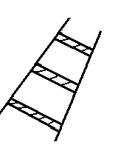
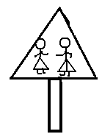
41. a) Name these road signs below.

___________________ __________________
b) How are road signs useful on the road?
___________________________________________
c) Give any one danger of road accidents.
___________________________________________
- 4 -

42. a) What are living things?
___________________________________________
___________________________________________
b) Give any three examples of living things in our school.
i) __________________________________________
ii)__________________________________________
iii)_________________________________________

43. a) What are legends?
___________________________________________
___________________________________________
b) Name any one example of a legend.
___________________________________________
c) Who is believed to be the first Muganda?
___________________________________________
d) Who was Nambi’s bad brother?
___________________________________________
44. a) What is weather?
___________________________________________
___________________________________________
b) Give any three types of weather.
i) _______________________________________
ii) _______________________________________
iii) _______________________________________
iv) _______________________________________
45. Give one product got from each of the following crops.
a) Cotton ________________________________
b) Tobacco ________________________________
b) Sisal ________________________________
c) Sugarcanes ________________________________
- 5 -
46. a) Match the items in group A with those in B.
A B
Kampala Water logged areas
Poultry North, South, East, West
Swamps Capital City of Uganda
Cardinal points Keeping of domestic birds

i) Kampala ________________________________
ii) Poultry ________________________________
iii) Swamps ________________________________
iii) Cardinal points ________________________________
47. a) Who is a child?
___________________________________________
___________________________________________
b) Give two roles of children at home.
i)__________________________________________
ii)__________________________________________
c) Write down any one form of child abuse.
___________________________________________
48. a) Name the place where pupils go to acquire knowledge and
skills.
___________________________________________
b) Write any three symbols of a school.
i) __________________________________________
ii)__________________________________________
iii)_________________________________________
49. a) Name any two components of weather.
i)____________________ ii)____________________
b) Give the component of weather that;
i) helps farmers in winnowing __________________
ii) dries harvested crops __________________
- 6 -

50. a) Which term is given to the four main points of a compass.
___________________________________________
b) Give any two main points of a compass.
i)__________________________________________
ii)__________________________________________
c) Identify any one group of people who use a compass.
i) __________________________________________
ii)__________________________________________
51. a) Name the largest lake in Uganda.
___________________________________________
b) Give two uses of lakes in Uganda.
i)__________________________________________
ii)__________________________________________
c) Who is a fisherman?
___________________________________________
52. a) Write down any two groups of people who maintain peace
and security at school.
i)__________________________________________
ii)__________________________________________
b) Give any two weapons used by the policemen to maintain
peace and security.
i)__________________________________________
ii)__________________________________________
- 7 -

53. a) Choose the best answer from given in this box to
complete the sentence below.
A medical assistant | A pharmacist | A surgeon
An oculist | A dentist

- _________________________ treats people’s teeth.
- __________________________ prepares medicine.
- _________________________ treats people’s eyes.
- _________________________ operates patients.
54. a) Draw the map of these objects.
a tree | a house
b) Give two ways of locating places and directions.
i)__________________________________________
ii)__________________________________________
55. a) State any four common accidents at home.
i)__________________________________________
ii)_________________________________________
iii)_________________________________________
iv)_________________________________________
***END***

MUSAB
END OF TERM TWO EXAMINATION FOR P.3 - 2019
SUBJECT: LITERACY ONE “A”
NAME: ………………………………………………………………………….
SCHOOL: ………………………………………………………………………….
STREAM: ………………………………. DATE: ………………………….

SECTION A:
1. Name the main natural source of light.
_______________________________________________
2. Which sense organ is used for tasting?
_______________________________________________
3. What is a family?
_______________________________________________
_______________________________________________
4. Name any one source of water in the environment.
_______________________________________________
5. Which type of gas do people breathe in?
_______________________________________________
6. What is wind?
_______________________________________________
_______________________________________________
7. Name any one wild animal you know.
_______________________________________________
8. Why do we clean our compound?
_______________________________________________
9. Give any one material used to clean our bodies.
_______________________________________________
10. How can we make water safe for drinking?
_______________________________________________
- 1 -
11. Apart from the sun, name any other source of light.
_______________________________________________
12. What is formed when plants and animals decay?
_______________________________________________
13. ___________________ is used for hearing.
14. Which part of air occupies the biggest percentage in the
atmosphere?
_______________________________________________
15. Why do you bathe?
_______________________________________________
16. Name any one plant you know.
_______________________________________________
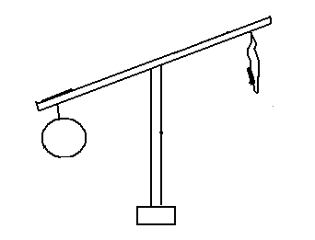
17. Which property of air is shown below?

________________________________

18. Name any one domestic animal that provides us with milk.
_______________________________________________
19. List down any one item used for cleaning our classroom.
_______________________________________________
20. Which layer of soil is the best for crop growing?
_______________________________________________
21. Tom was in class and heard a cow lowing, which sense organ did he use?
_______________________________________________
22. Name any one animal that is used for transport.
_______________________________________________
-2 –

23. Draw and name any one garden tool.

______________________

24. Which type of soil is used for modeling?
_______________________________________________
25. What is an accident?
_______________________________________________
_______________________________________________
26. Identify any one type of food you eat at school.
_______________________________________________
27. Write down any one danger of too much sunshine in the
environment.
_______________________________________________
28. What are living things?
_______________________________________________
_______________________________________________
29. Identify one material used by people in the rainy weather.
_______________________________________________
30. State any one cause of accidents at school.
_______________________________________________
31. Name any one source of carbohydrates.
_______________________________________________
32. What is the meaning of the word “environment?”
_______________________________________________
_______________________________________________
- 3 -
33. Give one importance of rain in the environment.
_______________________________________________
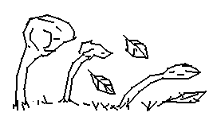
34. Which weather condition is shown below?

_____________________________

35. What is immunization?
_______________________________________________
_______________________________________________
36. A ___________________ is to man as a fry is to fish.
37. What name is given to moving air?
_______________________________________________
38. What do insects use for breathing?
_______________________________________________
_______________________________________________
39. Why do we cut our finger nails short?
_______________________________________________
40. Which layer of soil contains a lot of humus?
_______________________________________________

SECTION B:
41. a) Give any two gases that make up air.
i)__________________________________________
ii)__________________________________________
b) Suggest two uses of air you know.
i)__________________________________________
ii) _________________________________________
- 4 -

42. a) List down any four immunisable diseases.
i)__________________________________________
ii)__________________________________________
43. a) State any two common accidents at home.
i)__________________________________________
ii)__________________________________________
b) Suggest two ways of preventing accidents.
i)__________________________________________
ii)__________________________________________
44. a) Name any two examples of vegetable crops you know.
i)__________________________________________
ii)__________________________________________
b) Draw and name two fruits in your community.

45. Match these organs with their senses.
Ear seeing
Tongue feeling
Eyes hearing
Skin tasting

i) Ear - _____________________________
ii) Tongue - _____________________________
iii) Eyes - _____________________________
iv) Skin - _____________________________
- 5 -
46. a) Give any two uses of domestic animals.
i)__________________________________________
ii)__________________________________________
b) Suggest any one way of caring for domestic animals.
___________________________________________
c) Name any one item got from domestic animals
___________________________________________
47. List down four uses of water.
i)______________________________________________
ii)_____________________________________________
iii)_____________________________________________
iv) ____________________________________________
48. a) Which part of a mango do we eat?
___________________________________________
b) Give two examples of plants you know.
i)_____________________ ii)___________________
49. a) Name the three types of soil you know.
i)__________________________________________
ii)__________________________________________
iii)_________________________________________
b) Suggest any one use of soil.
___________________________________________
___________________________________________
50. a) Name the homes of the following animals.
i) cattle - _____________________
ii) birds - _____________________
iii) dogs - _____________________
iv) rabbits - _____________________
- 6 -

51. a) State any three components of soil.
i)__________________________________________
ii)__________________________________________
iii) _________________________________________
b) How is humus important in the soil?
___________________________________________
52. a) Name any four items used to keep your body clean.
i)____________________ ii)____________________
iii)____________________iv)___________________
53. a) Name any two important places of a clean home.
i)__________________________________________
ii)__________________________________________
- State any two materials we use to keep our school clean.
i)__________________________________________
ii)__________________________________________
54. a) Name any three sources of food in the environment.
i)___________________ ii)____________________
iii)__________________
b) State one use of food to your body.
___________________________________________
55. a) Which type of electricity is got from the sun?
___________________________________________
b) Write down any three uses of electricity.
i) _________________________________________
ii) _________________________________________
iii) _________________________________________
***END***

MUSAB
END OF TERM TWO EXAMINATION FOR P.3 - 2019
SUBJECT: ENGLISH
NAME: ………………………………………………………………………….
SCHOOL: ………………………………………………………………………….
STREAM: ………………………………. DATE: ………………………….

SECTION A:
Use the most correct word to fill in the gaps correctly.
1. How old are __________________________________?
2. The baby was suffering ________________measles.
3. Andy and Samuel are leaning _____________the wall.
4. Mr. Lutaabi, the __________________ has flown an aeroplane.
5. The cat was hiding ________________ the bed.
Fill in the gaps using the correct form of the words in brackets.

6. The dog is ________________ at school children now. (bark)
7. My father is a good ________________. (drive)
8. The _________________ has not marked our books. (teach)
9. Ruth was ___________________ than Ronald. (smart)
10. There are some ________________ on the plate. (fly)
Use the words in the sentences to show that you understand
their meaning
11. Weak _______________________________________
12. Week _______________________________________
- 1 -

Arrange the words in alphabetical order.
13. hoot, hive , he, hutch, hat
_______________________________________________
14. zebra, lion, monkey, donkey
_______________________________________________
15. ostrich, dog, frog, crocodile
_______________________________________________
Give the plural form of the underlined words in the sentences.
16. She has mango in the basket.
_______________________________________________
17. An ox is very strong.
_______________________________________________
18. We have furniture in our class.
_______________________________________________
Rewrite the sentences below giving the opposites of the underlined words.
19. Annet is taller than Ritah.
_______________________________________________
20. They have young sisters.
_______________________________________________
For questions 21 and 22 arrange the words to form correct
sentences.
21. is the Where girl?
_______________________________________________
22. was mouse hiding hole The a
_______________________________________________
- 2 -
Give a single word for the underlined group of words.
23. The young dog is not dangerous.
_______________________________________________
24. The person who sells fish is very hungry.
_______________________________________________
25. The head of school is a kind man.
_______________________________________________
Write the long forms of the following.
26. Mon. - ______________________
27. aren’t. - ______________________
28. Sch. - ______________________
Fill in the following using “some” or “any”
29. She has ________________ fruits in the basket.
30. There isn’t ______________ salt in the soup.
Rewrite as instructed in brackets.
31. Joan is not playing. Joan is sick. (Use: ……………because ………..)
_______________________________________________
_______________________________________________
32. The elephant is big. The cow is small. (Use:…………but……….)
_______________________________________________
_______________________________________________
33. This sheep is very small. (Begin: These …………………………)
_______________________________________________
_______________________________________________
34. Teddy has a new dress. (Underline the adjective)
- 3 -
35. Joyce is a prefect. Wilson is a prefect. (Use: …….and ……..)
_______________________________________________
_______________________________________________
36. This is the dentist. He treated my sick tooth.
(Join using: ……………who ………………)
_______________________________________________
_______________________________________________
37. Her name is Sarah. (Write a suitable question to this sentence)
_______________________________________________
_______________________________________________
38. I used an aeroplane. I was going to London. (Use: ……….as………)
_______________________________________________
_______________________________________________
39. Lutabi is big. Mubiru is bigger. (Use: ………….than…………….)
_______________________________________________
_______________________________________________
40. Namakula was drawing a picture. (Rewrite the sentence using a correct pronoun of the underlined noun)
_______________________________________________
_______________________________________________
41. The bird ate an apple. (Begin: Am apple………………………….)
_______________________________________________
_______________________________________________
42. Man is to house as lion is to ________________
(Complete the sentence correctly)
- 4 –
43. We like walking more than running. (Use: …………prefer………..)
_______________________________________________
_______________________________________________
44. That is the cook. His daughter was killed yesterday.
(Use: …………..whose………………….)
_______________________________________________
_______________________________________________
45. The boy is very young, she cannot go to school.
(Use: ……………too………….to………………)
______________________________________________
______________________________________________
46. These are the dogs. They poured my milk. (Use:…….which……….)
_______________________________________________
_______________________________________________
47. ritah was born on thursday. (Punctuate correctly)
_______________________________________________
_______________________________________________
48. Nakato is tall. Male is tall. (Use: …………..as………………as…………)
_______________________________________________
_______________________________________________
49. They are big. They can lift that table.
(Use: …………………..enough to…………………..)
_______________________________________________
50. One by one _____________________________________.
(Complete the proverb correctly?
- 5 -
SECTION B:
51. A. Use the table below to construct five sentences.

we | fire  chalk  water  flowers  sand | for | building  cooking  washing  decorating  writing

- ___________________________________________
- ___________________________________________
- ___________________________________________
- ___________________________________________
- ___________________________________________
B. Match the following correctly.
Animal sound
Monkey mews
Baby trumpets
Snake chatters
Cat cries
Elephant hisses

Monkey - _________________________
Baby - _________________________
Snake - _________________________
Cat - _________________________
Elephant - _________________________
- 6 –
52. Study the notice below and answer the questions that follow.

SPORTS DAY
SCHOOL : Kisolo Junior School
DATE ; Wednesday, 27th August, 2019
VENUE : School field
TIME : 2:00p.m - 5:00p.m
ENTRY : FREE TO ALL PARENTS
Come with a friend

Questions:
1. What is the notice about?
___________________________________________ ___________________________________________
2. Which school has the sports day?
___________________________________________ ___________________________________________
3. On which day will it take place?
___________________________________________
___________________________________________
4. When will the sports day start?
___________________________________________
___________________________________________
5. At what time will it end?
___________________________________________
___________________________________________

- 7 -
6. What should one come with?
___________________________________________
___________________________________________
7. Write Wed. in full.
___________________________________________
8. In which month will it take place?
___________________________________________
9. Give the opposite of friend.
___________________________________________
10. Find a word in the notice that means place.
___________________________________________
53. Read the story and answer questions about it in full sentences.
Amon goes to school every day. He studies at Victory Primary School. He is in class three and his class teacher is Miss Bityo. There are twenty-three boys and twenty-five girls in his class. Amon likes English lesson most but doesn’t like Science. Joseph, his friend likes Science but doesn’t like English. Both of them like music.
Questions:
1. In which school is Moses?
___________________________________________ ___________________________________________
2. Who is Moses’ friend?
___________________________________________ ___________________________________________
3. In which class is Moses?
___________________________________________
___________________________________________
- 8 -
4. How many pupils are there in Moses’ class?
___________________________________________
___________________________________________
5. Who is their class teacher?
___________________________________________
___________________________________________
6. Write Eng. in full.
___________________________________________
7. What two lesson does Joseph like?
___________________________________________
___________________________________________
8. Who doesn’t like English?
___________________________________________
___________________________________________
9. In which class do you think will Moses be next year?
___________________________________________
___________________________________________
10. Write twenty-three in figures.
___________________________________________

54. Read the poem and answer questions in full.
Dogs bark from their kennels,
1. Doves coo from their dove cots,
Whereas horses neigh from their stables.

From their habitats,
They bark, coo and neigh,
2. All to call for help in case of danger,
Look for friends,
And to get food.

- 9 –

As these creatures live with people,
3. Others wild birds, animals and insects.
Live in the bush, forests burrows and zoos

Such animals, birds and insects include,
4. Lions, peacock, monkey and many others,
But remembers, whether domestic or wild,
They are all important.

Questions:
- Which animal barks?
___________________________________________
- Which animals live in stables?
___________________________________________
- Give two reasons why animals bark and neigh.
i)__________________________________________
ii) _________________________________________
- Name one thing that people get from birds they rear at home.
___________________________________________
- How do we call animals that live in bushes and forests?
___________________________________________
- Mention any two domestic animals mentioned in the poem.
i)_____________________ii)____________________
- Are wild animals and birds important to us?
___________________________________________
- Write the opposite of peacock.
___________________________________________
-10-

55. Use the words below to fill in the gaps correctly.

drink, rivers, dirty, water, rubbish,
carefully, pots, good, sure, clean

Lakes and _________________are sources of water but sometimes this water is not clean. Animals walk in the rivers and lakes and ______________from them. They make the water ________________. Some people throw _________________ in the lakes and rivers. This makes the __________________dirty too. We need to keep the rivers and lakes _________________. We must keep the jerrycans, tanks and _______________ very clean.
We need to water plants __________________so that water is not washed. It is ______________for us to clean the wells and boreholes. We must make _________________that the taps do not drip as this wastes water

***END***

MUSAB
END OF TERM TWO EXAMINATION FOR P.3 - 2019
SUBJECT: RELIGIOUS EDUCATION
NAME: ………………………………………………………………………….
SCHOOL: ………………………………………………………………………….
STREAM: ………………………………. DATE: ………………………….

SECTION A: (40 Marks)

1. How many days did God take to create the earth?
_______________________________________________
2. Name the town where Jesus Christ was born.
_______________________________________________
3. What name is given to the fasting period for Christians?
_______________________________________________
4. Write the person who built the ark.
_______________________________________________
5. What name is given to the Holy Book for Christian?
_______________________________________________
6. Why do Christians pray?
_______________________________________________
_______________________________________________
7. Give any one way leaders are important in the church.
_______________________________________________
_______________________________________________
8. Who is a prophet?
_______________________________________________
_______________________________________________
9. Give one way children can show respect to elders.
_______________________________________________
-1-
10. Why do Christians go to church?
_______________________________________________
_______________________________________________
11. Name the Angel who brougt the good news about the birth of Jesus to Mary.
_______________________________________________
12. Mention one similar custom in Christianity and Islam. _______________________________________________
13. On which mountain did Moses receive the Ten Commandments?
_______________________________________________
14. Give one way a person becomes a leader.
_______________________________________________
_______________________________________________
15. Name the day when Christians go to church.
_______________________________________________
16. Why did God send Jesus Christ on earth?
_______________________________________________
_______________________________________________
17. Who was the wife of Abraham?
_______________________________________________
_______________________________________________
18. How did Adam and Eve disobey God?
_______________________________________________
_______________________________________________
19. Give any one way of caring for needy Christians.
_______________________________________________
_______________________________________________
20. What title is given to the leader of all Catholic in Uganda?
_______________________________________________
-2-
SECTION B: (60 Marks)
21. a) Name the river where Jesus Christ was baptized.
___________________________________________
b) Who baptized Jesus Christ?
___________________________________________
c) Give two reasons why Christians are baptized.
i) _________________________________________
ii) _________________________________________
22. Match the following days with their events.
a) Holy Thursday Jesus resurrected.
b) Easter Monday Jesus washed the feet of His
apostles.
c) Good Friday Jesus appeared to His apostles on
the way to Emmaus.
d) Easter Sunday Jesus was crucified.
Correct order
a) Holy Thursday - _____________________________
b) Easter Monday - _____________________________
c) Good Friday - _____________________________
d) Easter Sunday - _____________________________
23. a) What is a custom?
___________________________________________
___________________________________________
b) Mention any two examples of traditional customs in the
community.
i)__________________________________________
ii)__________________________________________
- How are customs important to the community?
___________________________________________
-3-

24. a) How many apostles did Jesus Christ have?
___________________________________________
b) Name any two of Jesus’ apostles.
i)__________________________________________
ii)__________________________________________
c) Name the apostle who preached on Pentecost day.
___________________________________________
25. a) Who is a leader?
___________________________________________
b) Name one example of a religious leader in Christianity.
___________________________________________
c) State two qualities of a good religious leader.
i)__________________________________________
ii)__________________________________________
26. a) Name any two prophets of God in the Bible.
i)__________________________________________
ii)__________________________________________
b) Which prophet of God was swallowed by a big fish?
___________________________________________
c) Mention one duty of God’s prophets.
___________________________________________
27. a) Mention any three miracles Jesus Christ performed.
i)__________________________________________
ii)__________________________________________
iii)_________________________________________
b) Which miracle did Jesus Christ perform at Cana?
___________________________________________
___________________________________________
-4-
28. a) On which day did God create man?
___________________________________________
b) Draw and name any two things God created.

c) Why did God create Adam?
___________________________________________
29. a) Give two ways God speaks to His people.
i)__________________________________________
ii)__________________________________________
b) Which book in Christianity is called the word of God?
___________________________________________
c) Mention one way people speak to God.
___________________________________________
30. a) Name the small god responsible for the following
i) babies - _____________________________
ii) war - _____________________________
b) What is the role of the following small gods?
i) Ddungu - _____________________________
_____________________________
ii) Musoke - _____________________________
_____________________________
-5-
31. a) Mention the day when Jesus entered Jerusalem in great
glory.
___________________________________________
a) On which animal did Jesus ride into Jerusalem?
___________________________________________
b) Why was Jesus Christ not happy when he entered the
Temple in Jerusalem?
___________________________________________
___________________________________________
c) State one way people disobey God’s house of worship
today.
___________________________________________
___________________________________________
32. a) Name any two sons of Adam and Eve.
i)__________________________________________
ii)__________________________________________
b) Which son of Adam killed the brother?
___________________________________________
c) How did God punish Adam’s son when he killed his
brother?
___________________________________________
33. a) Mention the two major parts of the Bible.
i)__________________________________________
ii)__________________________________________
b) Name any two books found in the Bible.
i)__________________________________________
ii)__________________________________________
-6-
34. a) Name the day when Jesus’ apostles received the Holy
Spirit
___________________________________________
b) Mention two gifts of the Holy Spirit.
i)__________________________________________
ii)__________________________________________
c) How important is the Holy Spirit to Christians?
___________________________________________
35. a) Give two examples of needy people in our community.
i)__________________________________________
ii)__________________________________________
b) State one way a P.3 pupil can help a needy person in our
community.
___________________________________________
___________________________________________
c) Why is a Christian supposed to help needy people?
___________________________________________
___________________________________________

***END***

MUSAB
END OF TERM TWO EXAMINATION FOR P.3 - 2019
SUBJECT: MATHEMATICS
NAME: ………………………………………………………………………….
SCHOOL: ………………………………………………………………………….
STREAM: ………………………………. DATE: ………………………….

SECTION A:
1. | Add: 154 + 32 | 2. | Find the value of 4 in the number 498.
3. | Set K = {2, 4, 5, 6, 8 } and set M = { 1, 3, 6, 7, 8}. Find K$∩$M | 4. | Name the figure below.  ___________
5. | Fill in the missing numbers.  5, 10, 15, 20, ___, ___ | 6. | Shade $\frac{2}{4}$ on the figure below
7. | Write 25 in Roman Numerals. | 8.  -1- | Maggie has 10 years and John has 8 years. Find their total age.

9. | Represent 243 on the abacus below.  O  T  H |  | 10. |  | One ball costs sh. 5000, what is the cost of 4 similar balls?
11. | Expand 724 |  | 12. |  | Find the missing number  + 4 = 12
13. | What number comes after 48? |  | 14. |  | Julius ate $\frac{2}{7}$ of his cake in the morning and $\frac{3}{7}$  in the evening. Find the fraction he ate altogether.
15. | Write the place value of 9 in 295. |  | 16.  -2- |  | Draw a set of 4 girls.
17. | If = 4 tomatoes. How many tomatoes are represented by ? |  | 18. |  | Arrange 4, 2, 9, 5 and 3 starting from the smallest
19. | Share 12 mangoes among 2 girls. |  | 20. |  | How many rectangles do you see?  ____________________
SECTION B:
21. | Study the Venn diagram below and answer questions that follow.  a) List all members of;  A  B  2  3  4  7  6  9  8  i) Set A  ii Set B  b) Find A$∩$ B c) Find A$∪B$
22. | Workout the following:
 | - $\frac{2}{9}+ \frac{3}{9} + \frac{1}{9}$ = | -3- |  | b) $\frac{11}{15} - \frac{7}{15} =$
23. | Given the digits 5, 3, and 7  a) Form the smallest number using the above digits.  b) Form the biggest number using the above digits.  c) Find the sum of the biggest and smallest umbers formed.
24. | Draw the following shapes.  Triangle Cylinder Square Kite  .
25. | Complete the table below.  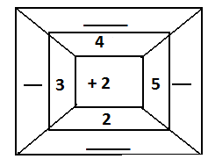
- 4 -
26. | a) Write 400 + 30 + 9 in short form.  b) Fill in correctly.  275 = ____hundreds ____tens ____ones
27. | 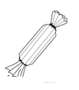Study the shopping below and answer questions which follow.  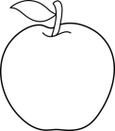  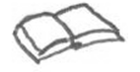  Sh. 800 Sh. 2000 Sh. 1000  a) How many items are in the shopping list above?  ___________________________________________  b) Name the cheapest item on the shopping list.  ___________________________________________  c) How much does a book cost more than an apple?
28. | Jolly had 25 dolls, his father bought him 15 more dolls.  a) How many dolls does he have altogether?  b) Find the difference between 853 and 521.
- 5 -
29. | Find the missing numbers.
 | a) x 5 = 10 | b) $÷$ 2 = 4
30. | Rhoda is 30 years old. Vicky is 20 years old.  a) Who is older?  b) Find the sum of the age.  c) What is the difference between 30years and 20 years?
31. | Cup A Cup B  30L  85L  a) ______________is bigger than ____________  b) How many litres are in Cup A more thank in Cup B?  c) Find the total litres in cup A and Cup B
- 6 -
32. | 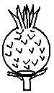Study the pictograph and use it to answer the questions which follow.  Benitah  Enid  Shirat  Immy  a) Who got the highest number of pineapples?  b) Which pupils got the same number of pineapple?  c) Ho many pineapples did Benitah get more than Immy?  d) Find the number of pineapples they got altogether.
***END***

MUSAB
EKIGEZO EKIKOMEKEREZA OLUSOMA OLW’OKUBIRI EKYA P.3 - 2019
SUBJECT: LUGANDA
NAME: ………………………………………………………………………….
SCHOOL: ………………………………………………………………………….
STREAM: ………………………………. DATE: ………………………….

1. Wandiika ebigambo bibiri (2) ebiwangaala ku buli nnyingo.
_______________ ________________
sii maa

________________ ________________

_______________
buu

_______________

2. Saza ku kigambo ekituufu ku bikuwereddwa.
a) edaggala amalagala eddagala eddaggala
b) omupiila Omupiira Omupira Omuppila
c) eliiso eriso eriiso eliso
d) ebaafu ebbaafu ebaaffu ebaaffuu
3. Wandiika ebigambo ebikontana no bino.
Emabega - _______________________________
muto - _______________________________
wansi - _______________________________
kirungi - _______________________________
- 1 -
4. Laga ennyingo ezikola ebigambo bino nga ozikutulamu.
ekiwaawaatiro - _____________________________
omusege - _____________________________
kalasamayanzi - _____________________________
ggwaatiro - _____________________________
5. Maliriza engero zino:
a) Akwata empola;
___________________________________________
b) Bamutangira mpiira;
___________________________________________
c) Abakadde abagalana
___________________________________________
___________________________________________
6. Wandiika obungi bwebigambo bino.
Empewo - ________________________________
Oluku - ________________________________
Amata - ________________________________
Omuti - ________________________________
7. Wandiika amannya g’emiwendo.
10 - _______________________________________
120 - _______________________________________
78 - _______________________________________
3 - _______________________________________
256 - _______________________________________
- 2 -

8. Kuba era otuume ebiwuka bisatu ebirina obulabe gyetuli.
9. Wandiika erinnya lyo eryekika wamu n’omuziro gw’ewedira.
a) __________________ b) __________________
10. Kabaka wa Buganda ye ______________________________
11. Omukulembeze wa Uganda ye _________________________
12. Wandiika amannya g’abaana ba Kabaka wa Buganda aliwo kati
a) Omumbejja - _____________________________
b) Omulangira - _____________________________
13. Wandiika ekigambo kimu ekitegeeza byonna.
a) Endaggu, Muwogo, Kasooli, Lumonde ________________
b) Obutungulu, Ennyaanya, Obunzaali _________________
c) Enkoko, Mbaata, Ssekokko __________________
d) Mbuzi, Ndiga, Mbwa, Kkapa ______________________
e) Mpale, Kkooti, Gomesi, Ssaati _____________________

- 4 –

14. Soma emboozi y’ababiri.
Musoke: Mpozi guno omwezi baguyita batya?
Musisi: Guno omwezi baguyita Mukulukusabitungotungo.
Musoke: Naye ng’enkuba etonya nnyo, n’amataba mangi kati.
Musisi: Kankubulire obutonde bwensi bwakyuse nnyo.
Musoke: Olowooza kivudde ku ki?
Musisi: Kivudde ku bintu ebikolebwa abantu ng’emikka emibi egiva mu makolero, ebintu ebyookyebwa abantu; ng’obuveera ne birala bingi byebisinze okwonoona obutonde bwaffe.
Musoke: Kati tukoze tutya?
Musisi: Buli muntu alina okukola nga akuuma obutonde bwensi.
Tuleme kutuna bizibu bino; enjala ani amuwadde akatebe?
Musoke: Kyandibadde kirungi tutandike okukunga abantu ngatuwereza n’ebirango abantu bona basobole okukuuma obutonde bwensi.

EBIBUUZO:
- Wandiika amannya g’abantu abali mu mboozi?
i)_____________________________
ii)__________________________
- Wandiika omutwe gwe mboozi.
___________________________________________
___________________________________________
- Wandiika ebintu ebimu ku byonona obutonde bw’ensi.
i)__________________________________________
ii)_________________________________________
BIKOMYE WANO

MUSAB
END OF TERM TWO EXAMINATION FOR P.2 - 2019
SUBJECT: MATHEMATICS
NAME: ………………………………………………………………………….
SCHOOL: ………………………………………………………………………….
STREAM: ………………………………. DATE: ………………………….

SECTION A:
1. | Fill in the missing numbers  600, 601, ___, 603, ___, 605, ___, 607 | 2. | A set is a __________  __________________  __________________
3. | Add: T O  2 8  + 1 4
4. | Arrange the numbers starting with the smallest  24, 26, 25, 23, 22 | 5. | Compare the sets.  C  B  A  Set ______has more members than set A or set B.  Set B has _____ members than set C
-1-
6. | Write in words.  46 _____________________________________  127 _____________________________________  4th _____________________________________
7. | What fraction is shaded?  = _______ = __________
8. | Fill in correctly.  a) 59 = ________tens and _____ones  - 764 = ______hundreds ____tens ____ones
9. | Draw hundred, tens and ones on the abacus below.  a) H T O b) H T O  = 236 = 521
10. | a) How many triangles  can you see?  _______________ |  |  | b)  -2- |  | Name these shapes.  _________  __________
11. | Divide:
 | a) 10 $÷$ 2 = ___ | b) 18 $÷$ 2 = ___ |  |  |  |  | c)  2 16
12. | Use $<$, $>$ or $=$ to complete correctly.  - 06 ______ 60  - 48 ______ 29  - 10 + 10 _______20
13. | a) Add:  4 5 2  + 3 2 5 |  | b) |  | John has 160 books. Joan has 429 books. How many books do they have altogether?
14. | 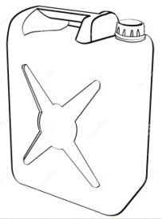  Compare using less or more.  a) A jerrycan holds __________water than a cup.  b) A cup holds ___________water than a jerrycan  -3-
SECTION B:
15. | Expand:  a) 12 = _____ + _________  b) 35 = _______ + ________  c) 125 = ______+ ______+ _______
16. | Write in words:  a) $\frac{1}{3}$ = ____________________  b) = _____________________  c) Add: $\frac{2}{5}$ + $\frac{1}{5}$ =
17. | Find the missing numbers.  a) + 4 = 10 b) 14 - = 7
18. | Dan had 68 pencils. He gave 14 pencils to his sister.  a) How many pencils did Dan remain with?  b) Subtract six from twelve.  -4-
19. | Four boys picked balls  Tom picked 3 balls  Tim picked 5 balls  Tonny picked 7 balls  Jimmy picked 3 balls  Questions:  a) Represent the above information on the graph  below.  Jimmy  Tonny  Tim  Tom  b) Who picked more number of balls?  c) Who picked the same number of balls?  d) How many balls do all the children have?
***END***
MUSAB
END OF TERM TWO EXAMINATION FOR P.2 - 2019
SUBJECT: LITERACY ONE “B”
NAME: ………………………………………………………………………….
SCHOOL: ………………………………………………………………………….
STREAM: ………………………………. DATE: ………………………….

SECTION A:
1. Name any two animals kept at home.
i) ____________________ ii)____________________
2. What is a school?
_______________________________________________
_______________________________________________
3. Apart from balls, give any other two things we make for playing.
i) ____________________ ii)____________________
4. Name any two people found in a nuclear family.
i) ____________________ ii)____________________
5. Who makes furniture?
______________________________________________
6. Give any two people found in a community.
i) ____________________ ii)____________________
7. Name any two school symbols.
i) ____________________ ii)____________________
8. A ____________________ is a group of people living together related by blood or marriage and adoption.
9. Why do people make mats in the community?
_______________________________________________
_______________________________________________
-1-
10. How do we call the acceptable way of behaving in the community?
_______________________________________________
11. Write down any two types of transport
i) ____________________ ii)____________________
12. Why do we need camels in the community?
_______________________________________________
13. Give the places of work for the following people below.
a) Carpenter - _____________________________
b) Pilot - _____________________________
c) Teacher - _____________________________
14. Name any two building materials made out of clay.
i) ____________________ ii)____________________
15. What is the common type of transport?
_______________________________________________
16. Apart from the garden, write other two sources of food people.
i) ____________________ ii)____________________
17. Name any two things we make from wood.
i) ____________________ ii)____________________
18. What is the source for wood?
_______________________________________________
19. Name these important places in the community.
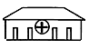 | 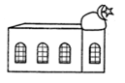
-2-
20. Name any two things found in the bedroom.
i) ____________________ ii)____________________
21. Write any two benefits of a school from the neighbours.
i) _____________________________________________
ii) _____________________________________________
22. What is the quickest means of transport?
_______________________________________________
23. What material is used to make mats?
_______________________________________________
24. Name one dangerous animal in the environment.
_______________________________________________
25. Name these means of transport.

 | 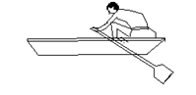 | 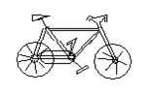
26. Write any two buildings found at school.
i) ____________________ ii)____________________
27. Give the roles of these people at school.
a) Headteacher - _____________________________
b) Cook - _____________________________
28. Name these traffic road signs.

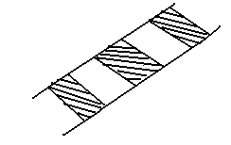 | 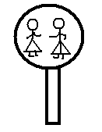 | 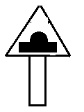
***END***

MUSAB
END OF TERM TWO EXAMINATION FOR P.2 - 2019
SUBJECT: LITERACY ONE “A”
NAME: ………………………………………………………………………….
SCHOOL: ………………………………………………………………………….
STREAM: ………………………………. DATE: ………………………….

SECTION A:
1. Give one example of a sense organ.
_______________________________________________
2. Which part of the body is used for biting?
______________________________________________

3. Name the garden tool used for transplanting young plants.
_______________________________________________
4. The general cleanliness of an area is called
_______________________________________________
5. Name one place at your school or home we need to keep clean.
_______________________________________________
6. From what product is yoghurt made?
_______________________________________________
7. Give one example of a fruit.
_______________________________________________
8. What name is given to a young one of a sheep?
_______________________________________________
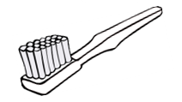
9. What name is given to the material below used to brush our teeth.

_________________________

-1-

10. How does a fish moves?
_______________________________________________
11. What does a fish use for breathing?
_______________________________________________
12. What are aquatic animals?
_______________________________________________
_______________________________________________
13. Name the part of a bird used for eating.
_______________________________________________
14. Give the name of this garden tool.
_____________________

15. How is the above tool useful to a farmer?
_______________________________________________
_______________________________________________
16. Mention one immunisable disease.
_______________________________________________
17. Give one characteristic of birds.
_______________________________________________
_______________________________________________
18. Identify one wild animal found in the bush.
_______________________________________________
19. Give one common accident at school.
_______________________________________________
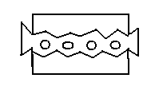
20. What is the use of the material below?
________________________________
________________________________
-2-

21. Why do animals move from one place to another?
_______________________________________________
_______________________________________________
22. How do we call a young one of a frog?
_______________________________________________
23. Give any two examples of plants that give us food?
i)_______________________ii)_____________________
24. Give one reason why people eat food.
_______________________________________________
_______________________________________________
25. Give any two uses of plants.
i) _____________________________________________
ii) _____________________________________________
26. Name one insect people eat.
_______________________________________________
27. Which organ does an insect breath through?
_______________________________________________
28. What is accident?
_______________________________________________
_______________________________________________
29. Identify one element of weather.
_______________________________________________
30. Name one material found in the first aid box.
_______________________________________________
31. Name the element of weather that moves things.
_______________________________________________
32. What is the main source of water?
_______________________________________________
-3-
33. Identify one use of water.
_______________________________________________
_______________________________________________
34. What animal provides ivory to people?
_______________________________________________
35. What animal uses horns for protection?
_______________________________________________
36. Where is the polio vaccine given?
_______________________________________________
37. Name one disease attacked by animals.
_______________________________________________
38. Which part of the body is used for talking?
_______________________________________________
39. Draw and name one dangerous material that cause accidents.

_________________________

40. Give the name of the place where dentists work.
_______________________________________________

SECTION B:
41. Identify two sources of water.
i) _____________________ ii) ______________________

42. Give the uses of the garden tools below.
a) trowel - ____________________________________
____________________________________
b) rake - ____________________________________
____________________________________
-4-
43. List any two dangers of accidents.
i)______________________________________________
ii) _____________________________________________
44. Draw and name two domestic animals.

45. Give the young ones of these animals.
a) hen__________________________________________
b) dog __________________________________________
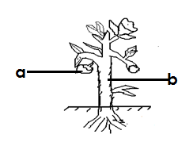
46. Name the parts of the plant labeled.

P ___________________
Q ___________________

47. Identify any two materials used to keep our bodies clean.
i)____________________ii)________________________
48. Apart from milk identify any other materials got from cows.
_______________________________________________
49. Write two tools used to keep the compound clean.
i)____________________ii)________________________
-5-
50. Write the movements of the animals below.
a) caterpillar - ______________________________
b) snake - ______________________________
51. Give the larva stages of these insects below.
a) housefly - ___________________________________
b) butterfly - ___________________________________
52. a) What is the second stage of a cockroach.
___________________________________________
b) Apart from a cockroach what other insect stages in dirty
places.
___________________________________________
53. Name two insects that go through four stages.
i)____________________ii)________________________
54. Suggest any two ways of keeping food safe.
i) _____________________________________________
ii) _____________________________________________
55. Give any two reasons why we brush teeth.
i) _____________________________________________
ii) _____________________________________________
56. Identify any two causes of accidents at home or school.
i) _____________________________________________
ii) _____________________________________________
57. Write down any two types of weather.
i)____________________ii)________________________
58. Give any two clothes used on a rainy weather.
i)____________________ii)________________________
***END***
MUSAB
END OF TERM TWO EXAMINATION FOR P.2 - 2019
SUBJECT: ENGLISH
NAME: ………………………………………………………………………….
SCHOOL: ………………………………………………………………………….
STREAM: ………………………………. DATE: ………………………….

SECTION A:
Fill in the missing letters.
1. p__lml___ ___ves 2. b___ ___k ___t
Rearrange the letters and form correct spelling.

3. briefs - _________ 4. salsi - _________
Arrange the words in their alphabetical order.
5. pestle, papyrus, pistal, pole
_________________________________________
6. slasher, stick, sickle, spade
_________________________________________
Write a little word from the words below
7. kitchen - ___________ 8. basket - __________
Underline the odd words.
9. ball, dolls, ropes, stones, pots
10. beetle, grasshoppers, leopard, crickets
Use the word in brackets and give its plural.
11. Their dog has four ______________. (puppy)
12. He has two ______________. (toy)
13. These _____________are ripe. (mango)
-1--
Write the following abbreviations in full
14. can’t ___________ 15. C/O _______________
Use the word in brackets and complete the sentences.
16. We _____________ a test every weekend. (write)
17. She _____________ grasshoppers every May. (fry)
18. Last month I ____________to Kampala . (go)
Fill the spaces with a correct word.
19. ____________is shouting loudly.
20. Peter is smarter ____________ John.
21. Do you ______________a brown dress.
22. Rita has _____________old umbrella.
23. ___________are the children doing?
24. Who _____________ a short pencil?
25. They _____________ writing an examination.
26. It ____________too sweet.
Fill the gaps with a correct preposition.
27. The aeroplane was flying _____________ the sky.
28. There is a snake ____________the cupboard and the
chair.
29. Elizabeth was playing __________ her doll.
30. Who was looking ____________ a knife?
Give the opposites of the underlined word.
31. My enemy is sick. __________________________
32. Who is smaller than Ritah? ____________________
33. She was drinking fruit. _______________________
-2-
Choose a correct word from the brackets and fill the spaces.
34. ______________ parents are doctors. (their, there)
35. ______________ was her uniform. (eat, it)
36. My daddy has a farm of __________. (ship, sheep)
Write as instructed.
37. This is the man. He stole the bull. (Use:…….who…….)
________________________________________
________________________________________
38. That is a rope. This is a ball (Use:…….and…….)
________________________________________
________________________________________
39. That is a butterfly. (Begin: Those………….)
________________________________________
________________________________________
40. Henry is a kind boy. He cannot help. (Use:…….but…….)
________________________________________
________________________________________
41. John is happy. He won the prize. (Use:……because…….)
________________________________________
________________________________________
Give one word for the list of underlined words in the sentence.
42. There are two young hens in the pen.
_________________________________________
43. We ate mangoes, oranges, apples and pineapples at the
party.
________________________________________
________________________________________
-3-
Use the word in brackets and complete the sentences correctly.
44. Who was the ____________ in your class. (one)
45. Mary is the ____________in their stream. (two)
Punctuate the following sentences correctly.
46. how old is your daughter?
_________________________________________
47. john gave me books pen pencils rulers and brooms.
_________________________________________
_________________________________________
Complete the sentences correctly.
48. I keep books in the library. Who am I?
_________________________________________
49. Musa sells meat. Who is he?
_________________________________________
SECTION B
50. Complete the table correctly.
Word | Comparative | Superlative
good | ____________ | best
__________ | worse | worst
big | bigger | ____________
__________ | lighter | lightest
heavy | ____________ | heaviest
-4-
51. Form sentences from the table.
We use | palmleaves  sisal  polythene  threads  papyrus | to make carpets.  to make sweaters.  to make mats.  to make ropes.  to make kites.

- ______________________________________
- ______________________________________
- ______________________________________
- ______________________________________
- ______________________________________
52. Arrange the sentences and form a good story.
1. Then he sold them and got money.
2. He put them under sunshine to dry.
3. He cut palmleaves.
4. He wove baskets and hats.
5. Juma went to the forest.

- ______________________________________
- ______________________________________
- ______________________________________
- ______________________________________
- ______________________________________
-5-
53. Use the words below and make a correct sentence.
a) They:
______________________________________
______________________________________
b) too :
______________________________________
______________________________________
c) to:
______________________________________
______________________________________
d) This:
______________________________________
______________________________________
e) These :
______________________________________
______________________________________
54. Read the poem and answer questions about it.
PALM LEAVEAS PALM LEAVES
Palm leaves Palm leaves palm leaves
Palm leaves are local materials,
Palm leaves are got from forests,
Palm leaves are sometimes green, yellow, red or purple.

Palm leaves Palm leaves palm leaves
Palm leaves are used to weave mats, hats and other things.
Palm leaves make good craft.
BY Annet Kirabo

-5-

Questions:
- What is the poem about?
______________________________________
______________________________________
- Write the title for the poem.
______________________________________
______________________________________
c) How many stanzas has the poem?
______________________________________
______________________________________
d) Where are palm leaves got?
______________________________________
______________________________________
e) Who wrote the poem?
______________________________________
______________________________________
***END***

MUSAB
END OF TERM TWO EXAMINATION FOR P.2 - 2019
SUBJECT: RELIGIOUS EDUCATION
NAME: ………………………………………………………………………….
SCHOOL: ………………………………………………………………………….
STREAM: ………………………………. DATE: ………………………….

1. Write R.E in full.
_________________________________________
2. Name any two activities done in the church.
i) ______________________________________
ii) ______________________________________
3. A holy place of worship for Christians is called
_________________________________________
4. When do Muslims go for Juman prayers?
_________________________________________
5. Name the king who wanted to kill baby Jesus.
_________________________________________
6. Where was Prophet Muhammad born?
_________________________________________
7. Write any two ways of showing respect to people.
i) ______________________________________
ii) ______________________________________
8. Give the meaning of these names
a) Emmanuel
______________________________________
b) Irene
______________________________________
-1-
9. What are living things?
_________________________________________
_________________________________________
10. What is a prayer?
_________________________________________
_________________________________________
11. Why do we pray?
_________________________________________
_________________________________________
12. How many apostles did Jesus have?
_________________________________________
13. Draw and name sources of light God/Allah created
a) | b)
c) | d)
- 2 -
14. Name any two Holy Books where we read the word of God/Allah.
i) ______________________________________
ii) ______________________________________
15. Identify one way of caring for the needy.
_________________________________________
_________________________________________
16. Who was the earthly father of Jesus Christ?
_________________________________________
17. Who was the first person God created?
_________________________________________
18. Who were the two sons of Adam?
i) ______________________________________
ii) ______________________________________
19. What is the Holy book for Muslims?
_________________________________________
20. Give two religious leaders in the Islamic region.
i) ______________________________________
ii) ______________________________________
21. Draw and name any two things found in the church.
a) | b)
- 3 -
22. Who is the head of the Moslem community?
_________________________________________
23. Write any two Moslem names.
i) ______________________________________
ii) ______________________________________
24. What did Jesus serve to his apostles during the last supper?
_________________________________________
25. What was the first miracle Jesus performed?
_________________________________________
_________________________________________
26. Identify two things that were used to kill Jesus.
i) ______________________________________
ii) ______________________________________
27. Give any two symbols of the Moslem religion.
i) ______________________________________
ii) ______________________________________
28. What did God create last?
_________________________________________
29. Who baptized Jesus Christ?
_________________________________________
30. Give the name of a prayer Jesus taught his apostles.
_________________________________________
31. Write down one leader from the Christian religion.
_________________________________________
- 4 -
32. Who was the helper of Jesus promised his apostles?
_________________________________________
33. Name the place where Jesus was crucified on the cross.
_________________________________________
34. Give one reason why Jesus died on the cross?
_________________________________________
_________________________________________
35. Name one pillar of the Moslem religion.
_________________________________________
36. Who was the mother of Prophet Muhammad?
_________________________________________
37. Where was Prophet Muhammad buried?
_________________________________________
38. Draw and name any two basic needs of people.
a) | b)
____________________ | ___________________
***END***

MUSAB
EKIGEZO EKIKOMEKEREZA OLUSOMA OLW’OKUBIRI EKYA P.2 - 2019
SUBJECT: LUGANDA
NAME: ………………………………………………………………………….
SCHOOL: ………………………………………………………………………….
STREAM: ………………………………. DATE: ………………………….

1. Soma okube ebisolo by’ewaka.
a) | b)
____________________ | ___________________
c)

-1-
2. Jjuzaamu ennyingo ezibulamu.
mba mbe _______ mbo mbu
nda _____ ndi ndo ndu
____ nfe nfi nfo nfu
nga nge ngi ngo ______
3. Kozesa ennyingo zino okole ebigambo.
lo
bi
bo
__________________________
______________________
______________________

nga

4. Wandiika ebintu bibiri byetufuna mu bisolo by’awaka.
i)__________________ ii)___________________
5. Tereeza ebigambo bino.
a) piiramu - ___________________
b) wansu - ___________________
c) keekamu - ___________________
d) wagumu - ___________________
6. Wandiika ebinyonyi bibiri ebisangibwa awaka.
i)__________________ ii)___________________
-2-
7. Saza ku kigambo ekituufu.
eriiso eliiso
ennyindo enyiindo
amattu amatu
eggalo engalo
8. Kola ennyingo okuva mu bigambo.
maama - ________________
ekikopo - ________________
embwa - ________________
embaata - ________________
9. Wandiika ennukuta ensirifu ssatu.
______ _______ _______
10. Soma okube ebidduka
emmotoka | endogoyi | eryato

-3-
11. Jjuzaamu ebigambo ebibulamu.
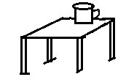
a) Ekikopo kiri ___________mmeeza.

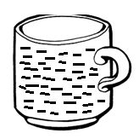

b) A mazzi gali __________kikopo.

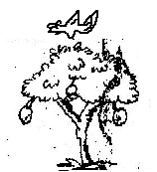

- Ekinyonyo kiri __________w’omuti.

12. Wandiika ebintu bibiri byetuzanyisa.
i)__________________ ii)___________________
13. Wa ennyumba zabino.
ekyenyanja - _____________
ente - _____________
enkima - _____________
14. Saza ku nsolo ezisangibwa mu nsiko.
ente, enjovu, kkapa
empologoma, embwa, engabi
-4-

15. Kozesa ennyingo okole ebigambo.
ba - ________________
la - ________________
ka - ________________
16. Tegeka ebigambo okole emboozi.
a) ewaka ekuuma Embwa.
______________________________________
______________________________________
b) emmeeza abajja Omusajja.
______________________________________
______________________________________
c) ku ntebe Ekikopo kiri.
______________________________________
______________________________________
d) omuguwa babuuka Abawala.
______________________________________
______________________________________

***BIKOMYE***

MUSAB
EKIGEZO EKIKOMEKEREZA OLUSOMA OLW’OKUBIRI EKYA P.1 - 2019
SUBJECT: LUGANDA
NAME: ………………………………………………………………………….
SCHOOL: ………………………………………………………………………….
STREAM: ………………………………. DATE: ………………………….

1. Wuliriza owandiike.
i)_________________ ii)_________________
iii)________________
2. Kuba olage embeera y’obudde.
ey'omusana | ey'enkuba
mbuyaga | kidedde
-1-
3. Jjuzaamu ebibulamu.
a e i o u
ba be ___ ___ bu
___ ne ni ___ nu
nsa ___ nsi ___ nsu

4. Menya ennukuta enjogeza.
_____ _____ _____ _____ _____
5. Kola ebigambo.
_________________

_________________
ba
wo
_________________
nsa
nsa
_________________
la
_________________
ka

6. Wandiika ennukuta ennene.
b B c ____ m _____
7. Kuba bino

ebire | enkuba | enjuba
-2-
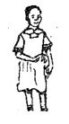
8. Bino biwe amannya.
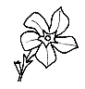

____________ ____________ _____________

9. Kola ebigambo.
ma mata
sa _________
ba _________
te _________
ye _________

10. Soma okube
manvuuli | gambutusi | esweta

11. Wandiika ennukuta ensirifu 3.
_____ _____ _____
-3-
12. Jjuzaamu ennukuta ezibulamu
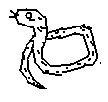
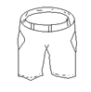

emp___l___ ens___w___ m___s___t___
13. Kutula ennyingo.
1. omusawo o-mu-sa-wo
2. olugoye ____________
3. ekibiina ____________
4. ettama ____________
5. funa ____________
14. Kuba ebitundu by’omubiri.

engalo | okugulu
15. Kuba akakubo.
amaaso kuwunyiriza
amatu kwogera
omumwa kulaba
ennyindo kuwulira
***BIKOMYE WANO***
MUSAB
END OF TERM TWO EXAMINATION FOR P.1- 2019
SUBJECT: RELIGIOUS EDUCATION
NAME: ………………………………………………………………………….
SCHOOL: ………………………………………………………………………….
STREAM: ………………………………. DATE: ………………………….

1. The name Peter means _______________________.

2. Jesus died on the _______________for our sins.
3. Write your religious name.
_________________________________________
4. God created people in His ______________________
(image, picture)
5. ____________________is the creator for Moslems.
6. Moslems pray _____________times a day.
7. Christians go to church to _____________________.
8. A _______________is a way of talking to God.
(player, prayer)
9. The prayer Jesus taught to His apostles is called _________________________________________
(Lord’s prayer, road’s prayer))
10. Name the creator for Christians. _________________________________________
-1-
11. Draw these ways of talking to God.
Preaching God’s word | Going to church

12. _________________was the earthly father of Jesus. (Joseph, James)
13. Christians talk to God by ______________________
(praying, playing)
14. ____________was the mother of prophet Muhammad. (Amina, Aisha)
15. Write any two Christian names for girls.
i) __________________ ii) __________________

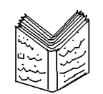16. Name these Holy Books.
(Quran, textbooks, Bible)
-2-
17. Draw and name the symbol found on the church.

18. Match correctly.
Good Friday Christians begin fasting
Palm Sunday Jesus died on the cross
Easter Sunday Jesus entered Jerusalem
Ash Wednesday Jesus rose from the dead.
19. Write two Muslim names
i)____________________ii)___________________
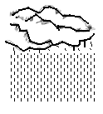
20. Name these things God created.

___________ __________ ___________
21. Muslims go to the _______________on Friday.
-3-
22. A ________________heads the Muslim community.
(Muft, pope)

23. Draw those needy people in the community.

The lame | The sick

24. Write any two needs of people.
i) _______________________________________
ii) _______________________________________
25. Christians go to __________________ on Sunday.
26. Jesus changed water into _____________________.
27. Circle the apostles of Jesus.
(Andrew, St. Kizito, Simon Peter, Gonzaga)
28. Write any two gifts God gave us.
i) ___________________ ii) __________________
29. Who leads Christians in the Mass?
_________________________________________
-4-
30. _________________ was the first apostles of Jesus.
(Andrew, Martin)
31. Jesus Christ ______________ the sick people.
(healed, heeled)
32. Jesus Christ loved by ____________for them.
( praying, fighting)
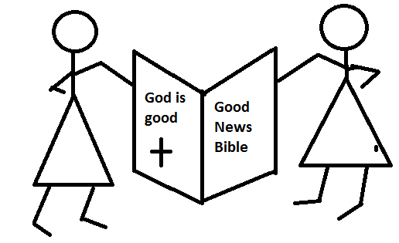
33. How do those people talk to God?

By ______________________

34. Fill in the missing letters.
A __ __ah, Q__r__n, B __ b __ e
C__ __ss
***END***

MUSAB
END OF TERM TWO EXAMINATION FOR P.1 - 2019
SUBJECT: LITERACY ONE “A”
NAME: ………………………………………………………………………….
SCHOOL: ………………………………………………………………………….
STREAM: ………………………………. DATE: ………………………….

1. Name this sense organ.
__________________

2. _______________is something good to eat or drink.
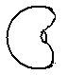
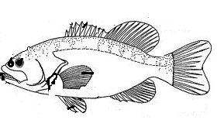
3. Name these foods we eat.

____________ ___________ __________

4. __________________treat sick people.
(nurses, doctors)

5. An _______________is a sudden injury to the body.
(accident, accept)

6. Name these things which cause accidents.

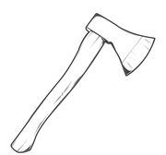 | 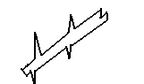

(razorblade, thorns, axe)
-1-
7. The first help given to an injured is called__________.
(first aid, fight)
8. The general cleanliness of a person is called ________________. (personal hygiene, healthy)
9. We must ________________ hands before and after eating food.
10. Name these things to clean our body.

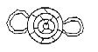

11. Write two domestic animals.
i) ___________________ii) __________________

12. Name the animals that give us milk.
_________________________________________
13. What insect gives us honey?
_________________________________________

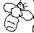
14. Name these accidents.
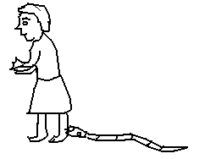
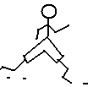

____________________ ___________________
(sting, snakebite)
-2-
15. We use eyes for ____________________________.
16. A _______________is used for digging.
17. A ________________is used for collecting grass.
18. Name these garden tools.

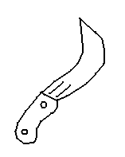 | 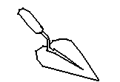 | 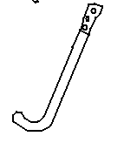
19. Circle the sources of food.
garden, hospital, shops, class, market
20. Match the tools to their uses.
sickle for slashing
panga for transplanting
slasher for cutting
21. Identify any two senses.
i) ___________________ii) __________________
-3-
22. Name these parts of the leg.
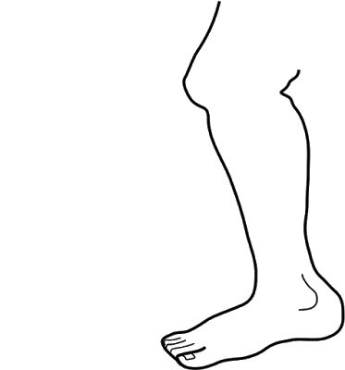
a _________________
b
a

c _________________
b _________________

c

24. What do we use for biting? (teeth, feet)
_______________________________________
25. We use a _________________and water to brush
teeth.
26. Match animals to their young ones.
Animal young one
dog cub
hen lamp
lion puppy
sheep chick
27. Fish live in ___________________.
29. Name these clothes used to manage weather.

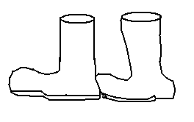 |  | 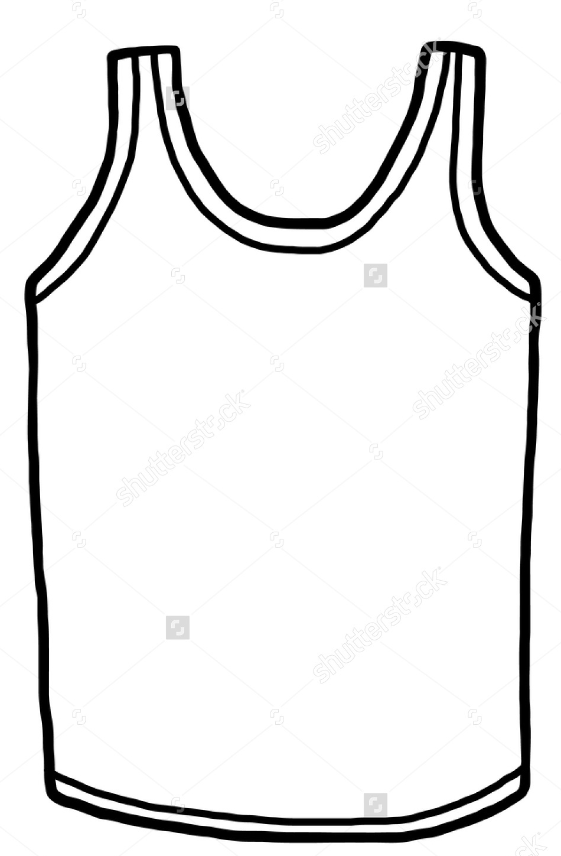
***END***
MUSAB
END OF TERM TWO EXAMINATION FOR P.1 - 2019
SUBJECT: LITERACY ONE “B”
NAME: ………………………………………………………………………….
SCHOOL: ………………………………………………………………………….
STREAM: ………………………………. DATE: ………………………….

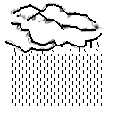
1. Name this element of weather.

__________________
2. Who heads a school? (teacher, headteacher)
_________________________________________
3. A teacher use __________________to write on the
chalkboard. (chalk, stick)
4. Write any two things we find in the classroom.
i) __________________ii) ____________________
5. Name these people we find at home.
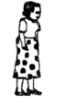 | 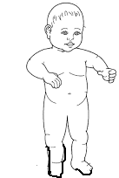
6. Circle the buildings we find at school.
hospital, kitchen, bank, latrine
- 1 -
7. Write the two seasons of the year.
i) _______________ season
ii) _______________season
8. Draw these types of weather
Sunny | Windy
9. Give the uses of these tools.
Brooms for _________________________________
Chalk for __________________________________
10. Name these school symbols.
ST. PAUL PRIMARY SCHOOL

11. Who cooks food at home?
_________________________________________
-2-
12. Match correctly.
teacher types exams
bursar teaches pupils
secretary collects school money
13. Name these important building in the community.
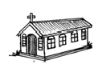 | 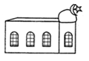 | 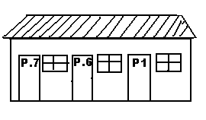

14. Write down two things we make.
i) ___________________ii) ___________________
15. Underline religious leaders in the community.
Bishops, policemen, pastors, teacher
16. Match people in the community to their places of work.
doctor lakes or rivers
pilots workshops
fishermen hospitals
carpenters airports
-3-
17. Name these things used at home.
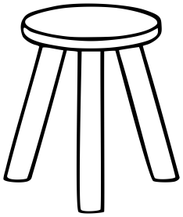 | 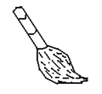 | 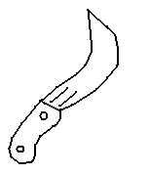
18. Match the animal to its home.
Animal Home
dog nest
bird bush
snake kennel
19. Draw these people in the community.
pilot | drivers
20. Name these basic needs of people.
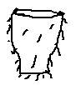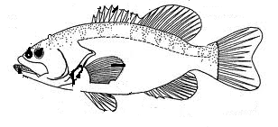  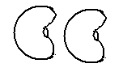 | 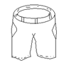
-4-
21. We use ___________________to build huts.
(grass, iron sheets)
22. A person who builds houses is called a ____________
(carpenter, builder)
23. Name the examples of houses.

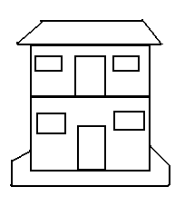
24. Write one person we find at school.
_________________________________________
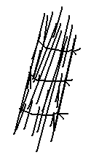
25. Name these building materials.

_____________ _____________

26. Write one thing we use at school.
_________________________________________

***END***

MUSAB
END OF TERM TWO EXAMINATION FOR P.1 - 2019
SUBJECT: ENGLISH
NAME: ………………………………………………………………………….
SCHOOL: ………………………………………………………………………….
STREAM: ………………………………. DATE: ………………………….

Fill in the missing letters.
1. s__h__ __l 2. th__rns 3. f___re
Read and draw.

4. Three flowers | 5. She is sitting on the mat

Arrange in ABC order.
6. girl, man woman boy
_________________________________________
7. desk, chair, book, flag
_________________________________________
Write a little word.
8. father - _____________ 9. dog - ___________
-1-
Write the plural word.
Singular Plural
10. box ______________
11. teacher ______________
12. mango ______________
Use Yes, it is a ……………… / No, it is not a ……………..
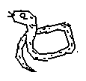
13. Is this a snake?
________________________________
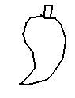
14. Is this a ball?
________________________________
Rewrite the words correctly.
15. uct - ___________ 16. snnyu - ____________
Write the action word.
verb action
17. sit ____________
18. write ____________
19. read ____________
20. carry ____________
Fill the gaps with “an” / “a”.
21. She has ____________apple.
22. There is ____________ knife in the basket.
-2-
Use the words in the brackets and fill the gaps.
(under, between, over, after)
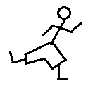
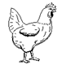
23. John is running ___________the hen.

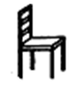
24 . The ball is _________the box and the chair.

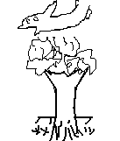
25. The aeroplane is flying _________the
tree.

26. There is a stone _________the bench.

Form sentences from the table.
I  She  They | has  have | a new uniform  ten sweets  long legs

27. _________________________________________
28. _________________________________________
29. _________________________________________
-3-
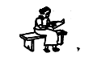
Complete the sentence correctly.
30. Mary is reading a ________________
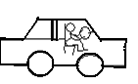
31. Alex is driving a ____________
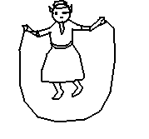
32. I am jumping a ____________

What are these?
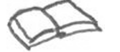
33.
___________________________
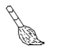
34.
___________________________

Fill in the correct number name.
35. Mother has ______________handbags. (4)
36. Those are ____________bricks. (9)
Read and tell the time.
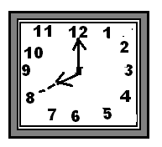

37. It is ____________ O’clock.

-4-
Arrange the words and form a correct sentence.
38. going school Mary is to.
_________________________________________
_________________________________________
39. kicking a He is ball.
_________________________________________
_________________________________________
Punctuate the sentences correctly.
40. this is a knife
_________________________________________
41. those are thorns
_________________________________________
Circle the odd word.
42. Two , play, Three, Five
43. cut, burn, fall, cloudy
Write in big letter.
44. bite - _____________
45. Use the words in the box and fill the gaps.
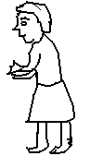
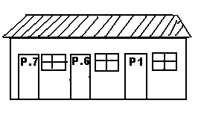(Annet, umbrella, rain, school, bag
One day Jane was going to ____________ .
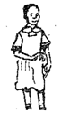
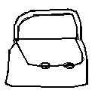
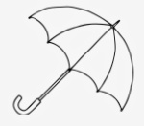
The ______________ started falling, Jane pulled her ______________ from the ___________
. Her friend ____________ joined her.
***END***
MUSAB
END OF TERM TWO EXAMINATION FOR P.1 - 2019
SUBJECT: MATHEMATICS
NAME: ………………………………………………………………………….
SCHOOL: ………………………………………………………………………….
STREAM: ………………………………. DATE: ………………………….

SECTION A:
1. | Add: b) T O  (a) 4 + 3 = ________ 3 6  + 1 2
2. | Draw the sets below.  a) An empty set. b) A set of 4 pineapples
3. | Fill in tens and ones.  45 = _______ Tens ______Ones  ________ = 3Tens 2 Ones.
- 2 -
4. | Name the sets below.  _____________________
5. | Take away.  a) 9 – 6 = ______ b) 1 1  - 3
6. | Complete the abacus.  a) T O b) T O  =  6  4
7. | 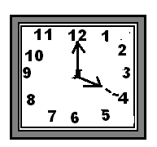Read and tell the time.  It is ___________O’clock.
8. | Fill in the missing numbers.  6  4  2  -3-
9. | Write the number name /word  8 = ______________________  11 = ______________________
SECTION B:
10. | Circle the bigger number.  a) 32 or 23  b) 14 or 41
11. | Draw bundles.  2Tens  3 Ones
12. | 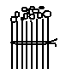Fill in correctly.  = ____________  __________Tens ______Ones  -4-
12. | Add using a numberline.  a) 2 + 3 = _____  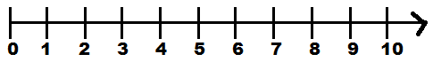  b) 5 + 0 = _______
13. | Multiply:  a) 3 x 3 = ______  b) 2 x 0 = ______
14. | Compare the sets using “less” or “more”  B  A  Set A has __________members  Set B has ___________members  -5-
15. | Name these shapes.  ______________ _______________  (triangle, circle, rectangle)
16. | Draw beads.  9 = 7 =
17. | Write the next number.  a) 13, 14, _____  b) 26, 27, 28 ____
18. | A _______________is a group or collection of things
19. | There are ____________days in a week.
20. | Fill in the missing letters.  M__n___d__y  T___esday  -6-
21. | Arrange the numbers in order.  5, 6, 2, 3, 1, 0  _____________________________________
22. | Add: Two books plus Two books equals ___________
23 | Mary has 4 balls. Jane has 6 balls.  Altogether they have _______________balls.
24. | + =
25. | Draw these shape.  Oval square  .
26. | a) Five minus Two equals _______________  b) Six minus Two equals _______________  -7-
27. | Shade the fraction.  = $\frac{1}{2}$
28. | Add the fraction.  $\frac{1}{2} + \frac{1}{3}$ =
29. | Match correctly  1st third  2nd tenth  3rd first  10th second
***END***

