KAMPALA JUNIOR ACADEMY
LOWER WORK TEST II 2020
PRIMARY SEVEN
SOCIAL STUDIES AND RELIGIOUS EDUCATION
Time allowed: 2 hours 15 minutes

Index No.

Candidate’s Name: _____________________________________________________
Candidate’s Signature: _________________________________________________
School Name: _________________________________________________________
FOR EXAMINER’S USE ONLY
Read the following instructions carefully:
- The paper has two sections: A and B
- Section A has 40 questions (40 marks)
FOR EXAMINER’S USE ONLY

Qn. No | MARK | SIGN
1 – 10
11 – 20
21 – 30
31 – 40
41 – 43
44 – 46
47 – 49
50 – 52
53 – 55
TOTAL

- Section B has 15 questions (60 marks)
- Answer ALL questions. All answers to both Sections A
and B must be written in the spaces provided.
- All answers must be written using a blue or black ball
point pen or ink. Diagrams should be drawn in pencil.
- Unnecessary crossing of work may lead to loss of marks.
- Any handwriting that cannot be easily read may lead to
loss of marks.
- Do not fill anything in the boxes indicated;
For Examiner’s use only.
Turn over

SECTION A (40 Marks)
(Questions 1 to 40 carry one mark each)
1. Name the major latitude in Uganda.
______________________________________________________________________
______________________________________________________________________
2. In which compass direction is Mount. Moroto from Mt. Rwenzori?
______________________________________________________________________
______________________________________________________________________
3. Give any one factor of climate which favours human settlement.
______________________________________________________________________
______________________________________________________________________
4. State one way in which forests contribute to rain formation.
______________________________________________________________________
______________________________________________________________________
5. Mention any one example of trees in a natural forest found in Uganda.
______________________________________________________________________
______________________________________________________________________
6. Why is wheat mostly grown in Kapchorwa and Bukwo districts?
______________________________________________________________________
______________________________________________________________________
7. In the space provided below, draw the map symbol for a dam.
______________________________________________________________________
______________________________________________________________________
8. Name the group of people who introduced cowrie shells as a form of money.
______________________________________________________________________
______________________________________________________________________
9. State any one way in which Lake Victoria provides employment to people.
______________________________________________________________________
______________________________________________________________________
10. Give one reason why the early Arabs did not spread Islam to many people.
______________________________________________________________________
______________________________________________________________________
11. Which mineral exists underground near Lake Albert?
______________________________________________________________________
______________________________________________________________________
12. Name the first European explorer to come to Uganda.
______________________________________________________________________
______________________________________________________________________
13. What is Alexander Mackay remembered for in Uganda?
______________________________________________________________________
______________________________________________________________________
14. What social service did Sir Hesketh Bell improve in Uganda during colonial period?
______________________________________________________________________
______________________________________________________________________
15. What was the cause of Lamogi rebellion?
______________________________________________________________________
______________________________________________________________________
16. Why was the national flag of Uganda raised on 9th October, 1962?
______________________________________________________________________
______________________________________________________________________
17. Which organ of government decides whether one has broken the law or not?
______________________________________________________________________
______________________________________________________________________
18. Why are there few people who grow tobacco in Uganda today?
______________________________________________________________________
______________________________________________________________________
19. Name one non-landlocked neigbour of Uganda.
______________________________________________________________________
______________________________________________________________________
20. Give one advantage of building on a hill.
______________________________________________________________________
______________________________________________________________________
21. What shows that Uganda is a God-fearing country on the coat of arms?
______________________________________________________________________
______________________________________________________________________
22. Name any one social activity in your community.
______________________________________________________________________
______________________________________________________________________
23. How many countries border East Africa?
______________________________________________________________________
24. State any one reason why it is important for a school to have prefects.
______________________________________________________________________
______________________________________________________________________
25. Give any one example of a resource.
______________________________________________________________________
______________________________________________________________________
26. Give any one way in which government gets money from tourism.
______________________________________________________________________
______________________________________________________________________
27. In which East African country were the Indian coolies used?
______________________________________________________________________
______________________________________________________________________
28. Give any one modern method of sending messages.
______________________________________________________________________
______________________________________________________________________
29. Give one reason why the quantity of fish in Lake Victoria is reducing.
______________________________________________________________________
______________________________________________________________________
30. Which country of East Africa was known as the “Mandated Territory”?
______________________________________________________________________
______________________________________________________________________
31. Give any one disadvantage of nomadic pastoralism.
______________________________________________________________________
______________________________________________________________________
32. State one way in which Uganda benefitted from the coming of Asians.
______________________________________________________________________
______________________________________________________________________
33. What was the major work of the Legislative Council (LegCo) in Uganda?
______________________________________________________________________
______________________________________________________________________
34. Name the feature on the Uganda coat of arms which shows the main economic activity.
______________________________________________________________________
______________________________________________________________________

35. State any one reason why a school may need a carpenter.
______________________________________________________________________
______________________________________________________________________
36. What colour is the uniform of the Police officer responsible for traffic?
______________________________________________________________________
______________________________________________________________________
For each of the questions 37 to 40, answer EITHER the Christian OR Islamic question but not both. No marks will be awarded to a candidate who attempts both alternatives in a number.
37. Either: How did Adam start to breathe?
______________________________________________________________________
____________________________________________________________________
Or: What was Allah’s purpose of creating Adam?
______________________________________________________________________
____________________________________________________________________
38. Either: Who accepted to sacrifice his son as God commanded?
____________________________________________________________________
____________________________________________________________________
Or: Who accepted to sacrifice his son by the command of Allah?
____________________________________________________________________
____________________________________________________________________
39. Either: How is death useful for a good Christian?
______________________________________________________________________
____________________________________________________________________
Or: How is death useful for a good Muslim?
______________________________________________________________________
____________________________________________________________________
40. Either: Why was King Herod not happy with the birth of Jesus?
____________________________________________________________________
____________________________________________________________________
Or: Why were some people in Mecca not happy with Prophet Muhammad (SAW)?
____________________________________________________________________
____________________________________________________________________

SECTION B (60 Marks)
(Questions 41 to 55 carry four marks each)
41. Complete the table below by either filling in the raw material used to produce the product given or the product made from the raw material given.
 | Raw material | Product
(i) | cotton | _________________________
(ii) | _______________________ | belts
(iii) | fur | _________________________
(iv) | _______________________ | cement

- (a) What is a land locked country?
________________________________________________________________
_________________________________________________________________
(b) Give one reason why most trade items imported into a landlocked country are sold at high prices.
________________________________________________________________
_________________________________________________________________
(c) Give two ways in which Uganda can solve the problems of being landlocked.
(i) _________________________________________________________________
_________________________________________________________________
(ii) _________________________________________________________________
_________________________________________________________________
43 (a) What is farming?
_________________________________________________________________
________________________________________________________________
(b) Suggest the method of crop farming suitable in dry areas.
_________________________________________________________________
_________________________________________________________________
(c) Give any two reasons why some places receive a lot of rain.
(i) _________________________________________________________________
_________________________________________________________________
(ii) _________________________________________________________________
_________________________________________________________________
44 (a) What is an economic activity?
________________________________________________________________
_________________________________________________________________
(b) Name the main economic activity of people in rural areas.
________________________________________________________________
_________________________________________________________________
(c) Give any two problems people in rural areas face as they carry out the activity named above.
(i) ________________________________________________________________
_________________________________________________________________
(ii) ________________________________________________________________
_________________________________________________________________
45. Study the map of East Africa below and answer the questions that follow.
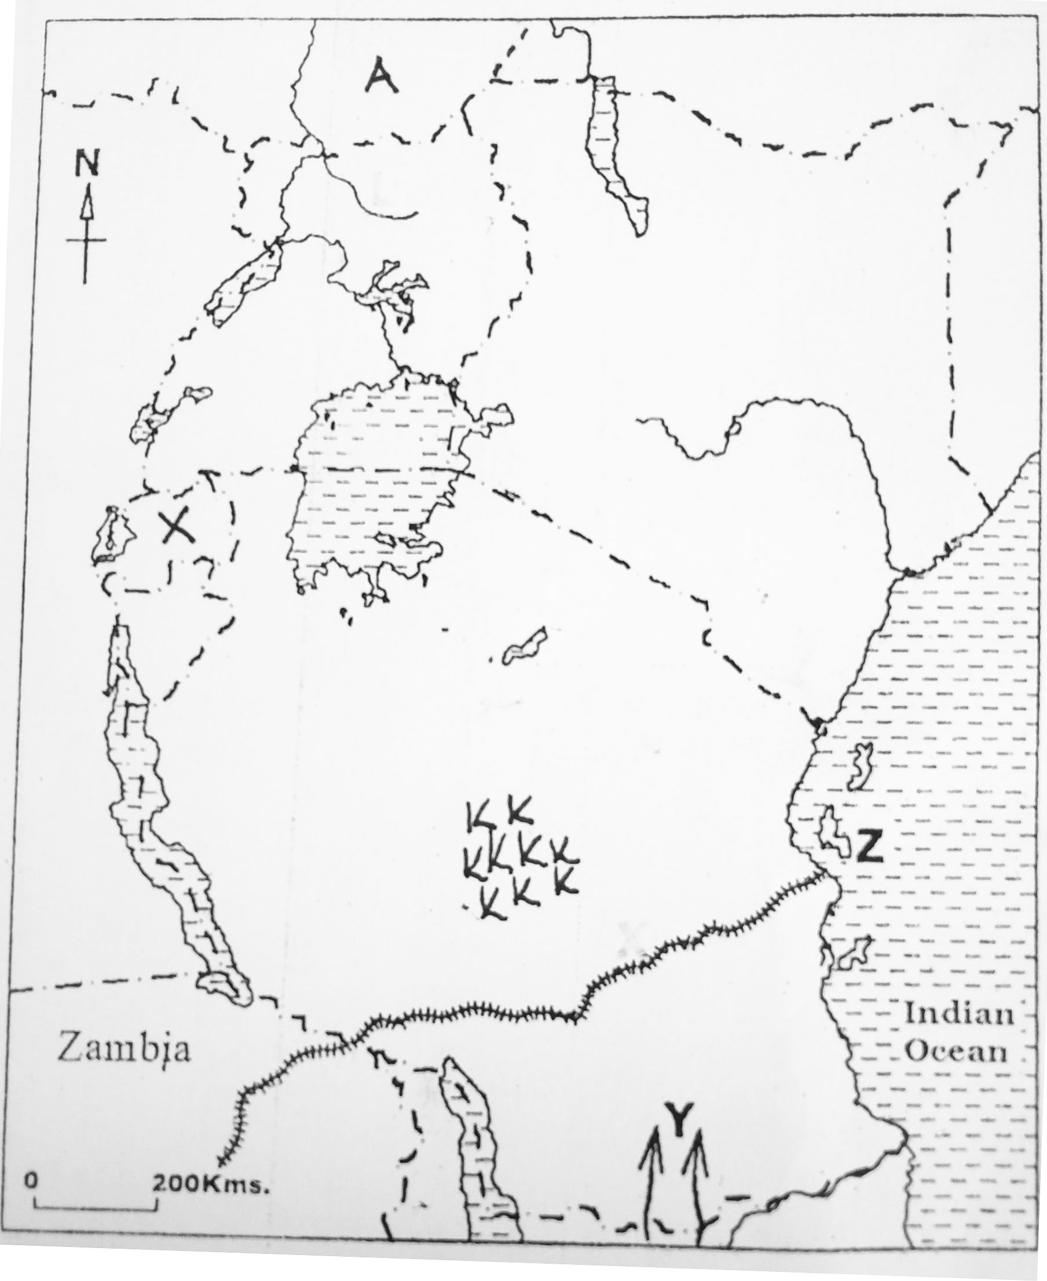
(a) Name the country marked with letter A.
_________________________________________________________________
(b) Which ethnic group entered East Africa using route marked Y?
_________________________________________________________________
(c) Why is the keeping of cattle difficult in the area labelled KK?
________________________________________________________________
_________________________________________________________________
(d) Why is there high population density in the country marked X?
_________________________________________________________________
_________________________________________________________________
46. (a) Apart from the Church Missionary Society (CMS), name any other group of missionaries that came to Uganda.
_________________________________________________________________
_________________________________________________________________
(b) Name any two social services which the missionaries promoted in Uganda.
(i) ________________________________________________________________
(ii) _________________________________________________________________
(c) Why did the missionaries teach people reading and writing skills?
________________________________________________________________
_________________________________________________________________
47. (a) Who was the last British governor in Uganda?
_________________________________________________________________
_________________________________________________________________
(b) Why did the colonial government encourage the formation of political parties in Uganda?
_________________________________________________________________
_________________________________________________________________
(c) Who founded the first political party in Uganda?
_________________________________________________________________
_________________________________________________________________
(d) State the year when the first elections based on political parties were held in Uganda.
_________________________________________________________________
_________________________________________________________________
48. (a) Name the first form of money to be used in Uganda.
_________________________________________________________________
(b) Give one reason why the Central Bank (Bank of Uganda) is important to the government.
_________________________________________________________________
_________________________________________________________________
(c) What title is given to the money used in Uganda?
________________________________________________________________
(d) State one reason why people look for money.
________________________________________________________________
_________________________________________________________________
49. (a) What is the main duty of the Judiciary?
_________________________________________________________________
_________________________________________________________________
(b) What title is given to the head of the Judiciary in Uganda?
_______________________________________________________________
______________________________________________________________
(c) How does the Prisons department help the courts of law to carry out their activities?
_________________________________________________________________
_________________________________________________________________
(d) Why does the Police take suspects to court?
_________________________________________________________________
_________________________________________________________________
50. (a) Give any two kinds of people that can receive help from the Red Cross Society of Uganda.
(i) _________________________________________________________________
(ii) _________________________________________________________________
(b) State any two ways in which the Red Cross helps people affected by war.
(i) ________________________________________________________________
________________________________________________________________
(ii) ________________________________________________________________
_________________________________________________________________

For each of the questions 51 to 55, answer EITHER the Christian OR the Islamic questions, but not both. No marks will be awarded to a candidate who attempts both alternatives.
51. Either:
(a) In which town was Jesus born?
_______________________________________________________________
_________________________________________________________________

(b) What was the occupation of Joseph?
_________________________________________________________________
_________________________________________________________________
(c) How was the coming of Jesus important to people?
_________________________________________________________________
_________________________________________________________________
(d) According to the Bible, why did Jesus go back to Heaven?
_________________________________________________________________
_________________________________________________________________
Or: Give the meaning of each of the following words.
(a) Hegira _________________________________________________________________
_________________________________________________________________
(b) Hijja
_________________________________________________________________
_________________________________________________________________
(c) Asalaam alleikum
_________________________________________________________________
_________________________________________________________________
(d) Miraj
_________________________________________________________________
_________________________________________________________________
52. Either:
(a) Name the disciple who betrayed Jesus.
_________________________________________________________________
(b) How did the disciple named above betray Jesus?
_________________________________________________________________
_________________________________________________________________
(c) What did Jesus do in the place called Gethsemane?
_________________________________________________________________
_________________________________________________________________
(d) How did the disciple named in 52 (a) die?
_________________________________________________________________
_________________________________________________________________

Or:
(a) Name the Prophet who built the ark.
_________________________________________________________________
_________________________________________________________________
(b) Why did the prophet named above build the ark?
________________________________________________________________
_________________________________________________________________
(c) Mention the mountain where the ark rested.
_________________________________________________________________
_________________________________________________________________
(d) What kind of people entered the ark?
_________________________________________________________________
_________________________________________________________________
53. Either:
(a) According to the story of Exodus in the Bible, who was the father of Joseph that was sold to Egypt?
_________________________________________________________________
_________________________________________________________________
(b) Give one reason why the Israelites went to live in Egypt.
_________________________________________________________________
_________________________________________________________________
(c) How were the Israelites able to cross the Red Sea?
_________________________________________________________________
_________________________________________________________________
(d) Where were the Israelites going when they crossed the Red Sea?
_________________________________________________________________
_________________________________________________________________
Or:
(a) Name the angel who revealed the Qur’an to Prophet Muhammad.
_________________________________________________________________
(b) Mention any three characteristics of Allah’s angels.
(i) _________________________________________________________________
(ii) _________________________________________________________________
(iii) _________________________________________________________________

54. Either:
(a) What is leadership?
_________________________________________________________________
_________________________________________________________________
(b) Give any three qualities of a good leader.
(i) _________________________________________________________________
(ii) _________________________________________________________________
(iii) _________________________________________________________________
Or:
(a) Mention any two divine books.
(i) _________________________________________________________________
(ii) _________________________________________________________________
(b) In which language were the above books written?
_________________________________________________________________
_________________________________________________________________
- Name the place where one can find divine books.
_________________________________________________________________
_________________________________________________________________
55. Either:
(a) Give any two things that happened to the apostles on Pentecost Day.
(i) _________________________________________________________________
_________________________________________________________________
(ii) _________________________________________________________________
_________________________________________________________________
(b) Name the person who was chosen to replace Judas Iscariot as the twelfth apostle.
_________________________________________________________________
(c) Give any one way in which the Holy Spirit was helpful to the apostles.
_________________________________________________________________
_________________________________________________________________
Or:
(a) Outline four things that can spoil prayer (salaat)
(i) _________________________________________________________________
(ii) _________________________________________________________________
(iii) _________________________________________________________________
- _________________________________________________________________
Good luck

